ICT10001: PROBLEM SOLVING WITH ICT

**Assignment 2B: Final report**

## EXECUTIVE SUMMARY

**Problem statement**

Baby Hut, a growing business of rental and buying baby equipment, notice the problems with their management system and seeking help from IT consultants. From their case study, it can be concluded that a online website is needed to develop to improve CRM (Customer Relationship Management) of the company. Moreover, a suggestion to improve the company operation system is provided as well.

**Company and opportunity**

When the three co-founders start on this business, little did they know their business would be this successful. From a single local store, Baby Hut now have five different stores in Melbourne which can expand into a store chain and available from any area of Australia. As rental business is quite rare in the market, the company has a perfect chance to achieve this opportunity to grow the business much broader.

With our team’s website solution, this future vision would be more likely to happen.

**Final solution**

The website is built based on WordPress and includes powerful functions. The vivid, beautiful interface should make a great impression with the customers. Additionally, the navigation bar is carefully setting up for easy surfing with the website. Our team ensure of great E-commerce functions in our website, making customers feel enjoyable with their shopping experience. The website also consists of various plugins to make the website secure and work more effective.

**Final thoughts & next steps**

Our website and management system changes solution for Baby Hut is inevitably perfect for the business. It would help to expand the brand much further by not only improve the communication between company and customers online but also provide an user-friendly interface of online store, increasing the chances of gain more revenue.

However, this solution would not stop here. As the business continue to expand day by day, the solution will too improve to optimize its performance.

Table of Contents

EXECUTIVE SUMMARY 1

1. INTRODUCTION 3

2. BODY 4

2.1. Project client and team members 4

2.2. Organisation background 4

2.3. Problem and project scope 5

2.4. Methodology 5

2.5. Results 8

2.6. Change management 9

2.7. Recommendations for future 10

3. CONCLUSION 12

4. APPENDIX 13

USER GUIDE 13

5. REFERENCE LIST 69

# 1. INTRODUCTION

Our client – Baby Hut, is a growing chain of sales and rental of baby equipment established a few years ago by three people: Peter Hamill, James George, and Angel White. With the success of their stores recently and the chance of expanding their business, they are now searching for opportunities in the online market. Yet there are several problems with their expanding plans.

To solve the company's problems, our team has been working on a project and came up with a website that could benefit their plan in expanding into the online market. In this report, we will first introduce the project background and restate the problem. In the next part, the methodology used for our project and our result achievement would be explained. However, our solutions to their issues still have limitations. As such, we would cover that area and give further recommendations for change management and the future of the business.

# 2. BODY

## 2.1. Project client and team members

Baby Hut company founder team would be the project client, which is Angel, Peter, and James. For the members of our team, there are:

* Nguyen Tran Mai Phuong – Leader
* Le Hoang Hai – Specialist
* Do Long Duy – Monitor evaluator
* Nguyen Huynh Quoc Bao – Teamworker.

Our team organizes meetings occasionally to give feedback on each other’s work. Moreover, we also make sure to give the founder team of Baby Hut insights into what we are developing throughout the project building period. Therefore, the final solution is the most suitable for both teams.

## 2.2. Organisation background

Baby Hut is a company that specializes in selling and leasing baby equipment, established by three young entrepreneurs: Peter Hamill, James George, and Angel White. The company has successfully carved out a niche for itself in the market, despite many of its competitors may have much more advanced equipment, largely thanks to their multitude of choices from pickup and delivery, a much wider range of equipment allow customers to purchase. Facing the need to expand the company at the moment, the company should be able to utilize online and mobile technologies thanks to the new website for the company.

## 2.3. Problem and project scope

**Problems:**

Although the company has been successful in its past iteration, there were two main issues that would hamper its expansion of the company. The first challenge was the lack of unity and timely communication between each store that would have caused huge inefficiencies, potentially harming the company in large ways if it were not properly dealt with. For the second challenge, the customer’s overreliance on the expertise of staff members for their needs, which for the company to expand, will receive a large influx of new inexperienced employees that would make it hard for the company to rely on the staff expertise when serving customers.

**Boundaries:**

Due to the fact that the main customers of Baby Hut are located in Australia, the website's only language will be English as any other language would be out of scope considering the company mainly works in the domestic market. Beside that, the messaging function will be mainly used for interaction between the customers and the employees with any related question to the products or services of the company, therefore chatting sessions between customers would be out of scope. And because Baby Hut is its own product and service provider, its search engine will only recommend the products or services inside the website, any products and services would be out of scope.

**Deliverables:**

The website is extremely user-friendly and even people with no experience in shopping online can use it easily and effectively thanks to its basic functions coupled with clear and simple navigation. Moreover, the website including an account management system, allowing users to create their accounts for storing information. However, it is not compulsory to register for an account. Therefore, the website can be used perfectly with all functions with no account needed. It also has easy maintenance and upgrading so that it will not take too much time before the server goes online again. Being “mobile-friendly” is also a key attribute of the website, as it would be much more convenient for customers to use the website from their mobile devices. Search engines have been optimized to give the exact result that customers are looking for.

## 2.4. Methodology

To solve the problems presented to us, we decided to incorporate the software WordPress to create the business website, this is due to the fact that it's easy to manipulate content from the backend which was one of James' concerns when managing a website.

Facing these challenges, the solution that we came up with is to incorporate the software WordPress into the business website as not only is it easier and cost less time and money to build the website with WordPress compare to building it out of scratch using code, but also because it contains a wide array of plugins that would immensely benefit the website. Moreover, WordPress is extremely popular and many of the websites available on the internet now are powered by WordPress. Therefore, the software is proved to be reliable and effective for the market.

The main method that we use is the Agile methodology, as we have many phases that after each one we developed, we take the input of our clients. The main reason we choose this method is that it is very flexible, agile and it also encourages the interaction between us - the developers and the clients. The project was divided into several building and testing period, allowing developers to see their process on the website as well as what our solution at that time is capable of and is not. Each phase of building the website has their own goals and number of tasks. Therefore, it is would be challenging to keep track and complete all these tasks on time. However, our team has worked with each other and communicate with Baby Hut representatives effectively, so that was not make this project hard for us. As our team has followed this method of project management, we manage to come up with a solid solution and solve the problem for the company. Also, taking into account the size and complexity of Baby Hut, we deemed that this approach would be much better for the longevity of the company as the Waterfall methodology would be more costly and time-consuming for Baby Hut. As an online store need to be update time by time, Waterfall methodology would inevitably make the updating process harder and much more challenging as well as ineffective.

We build the website using the Elementor plugin as it would help us out with the process, and we use the Astra theme to create the framework of the site. For easy help with business processes, we decided to use the WooCommerce plugin which would help us in creating a great business website for the company, but it also supports other plugins such as WooCommerce EasyBooking which would easily allow us to make the booking process suitable for James demand, or the WooCommerce Paypal Payment plugin that allow us to receive money digitally. To keep track of the data such as user interactions, sales numbers, we decided to integrate Google Analytics into the website and its WooCommerce support to help with providing data for the website to help James with the decision making process in the future. For security problems which was also one of the main concerns of our clients, we installed Jetpack which will backup our database and prevent data loss as well as hacker. For the final important component, which was search engine optimization, we decided to use Rank Math for our SEO plugin. Not only is it extremely easy to use for our website but it is also accurate which can help to accommodate customers' needs much better. Although there are many more plugins in our website, those are the main one that will be the solution for the challenges that Baby Hut face when it comes to expanding their size.

## 2.5. Results

As soon as we had a contract with the company, our team had considered the problems to find out a suitable solution, we have finally successfully developed a database server for an official online store for Baby Hut that has a fully-features to be friendly for users. The database is adjusted to have the finest security as well as optimized to reduce the latency. Therefore, the solutions that we set out can create an advantage not only for the company can sell more products, but also opens a new process for managing the whole company operating system.

The method here is a unique database between the retail store, it will lead to the consistency of every product. When a product is sold, imported, or rented, it will automatically be updated to the database immediately, all information about the product such as quality, price, orders will be recorded with the lowest error rate. Besides that, the manager who had the administrator role can control and manage those indexes. The new unique database will cost more every month for the business, however, it will eliminate the lack of unity in the system and increase the reliability and responsiveness of each store, additionally, the high-level manager can control their business better.

It is clear that based on the size of the Baby Hut business, the security of the database is seriously important when it contains the company’s sensitive information. Our team approaches many security layers. Firstly, all users or customers must create strong passwords that are twelve characters long, contains uppercase letters, lowercase letters, numbers, and special characters. The administer will need a second authentication in order to access the database. In case someone types in the wrong password for more than five times, the security will block that account and its IP address. Secondly, the website is developed based on the popular open-source WordPress software. As such, the URL “wp-admin” to login to the admin database would be easy to discover. To hide that information, we applied tools to replace that URL with another one. This should ensure that only people who have authority can get access to the admin dashboard. Thirdly, the system will scan for specious files and isolation. When the system recognizes any danger, all the suspect IP addresses would be banned immediately. Finally, to avoid data loss, our team highly recommend the backup process to be done manually by employees of the company. As it would take a huge storage and make the website unstable, automatic backup has not been installed for the solution. Moreover, backing up by hand would minimize the system error, thus reduce financial loss for any issues occur.

The process of creating the user interface took our team much attention as it is very important since the website is the face to convince customers to buy products. We used pink as our main color which is best suitable for a baby equipment store like Baby Hut. Also, a logo is exclusiveness created, as well as the slogan “Everything for your babies' needs!”. In addition, the header bar contains all requirements from our clients which are the main homepage, the products page with many filters, information about the site, team, and our contact, the account navigation bar for personal setup, and the search engine tool. These features are developed to get the best not only interaction but also attention to the customer. At the bottom, we design a footer to conclude more social media platforms for Baby Hut. The menu bar is designed to be friendly for users to access with categories and brands navigator for customers. To get a high recommendation from Google on each product, SEO is highly taken into consideration for each product’s content. Therefore, focus keywords and product tags are included. Moreover, the products’ descriptions and images are well-written and well-chosen for a better shopping experience. The system of comments and user accounts is also provided for the customer to keep track of their own orders and to get long-term benefits such as vouchers. The Baby Hut also has a rental system, so we integrated a rental choice directly on the product which can be rented.

All of the team members worked very effectively to publish the database website for our client Baby Hut. The solution to come up to solve all the existing problems in the Baby Hut system right now. Moreover, this solution can adjust the management system in a beneficial way and it is prospected to attract a huge number of virtual customers as well as create a number of careers in the business. This website is a demo and will be upgraded further in the future.

## 2.6. Change management

According to the solution that our team set out above, the way that Baby Hut's business operated needs to be improved. At the moment, retail stores in the chain are working stably and basically do not need to adjust very much. The solution of opening a unique database require them to update data into the database server, the business will need a period to adopt a new way of management, however, training employee is still necessary for managing and updating work to the server. The database for a business will cost a lot of money, so the skillful employees can not be irreplaceable for the growth of the business in the future. Let us discuss the control of the database, James George is a businessman who is one in three people responsible for business opportunities and managing the operating system. When we published the official website store, James would become the administrator and as well as the permission to become the manager of the database. He may wish to consider joining a course about the database as well as a class about WordPress in order to understand how the new system works. We have already integrated three new social media platforms Facebook, Instagram, and Twitter for the business which can build up the popularity of Baby Hut throughout the Internet, this will require the business a new position such as a content creator, video editor, photographer. Last but not least, shopping online became a part of customer life, when the COVID19 pandemic occurs, when the city was locked down, people could not go out shopping so online shopping will become the best choice. Based on that, we would suggest that Baby Hut should invest more money in the online business which is fit for the business’s trends as well as better security, faster loading, and a larger database system to satisfy customer.

## 2.7. Recommendations for future

Despite the effectiveness of our solution, flaws will still be inevitable for the website. We offer a few key aspects where our resolution might be improved to provide more commercial prospects in the future for future developments.

The website can now only display the item stock of the entire company. However, it cannot display the number of stores, addresses, or stock information about each store. In the future, the website can be further enhanced with separate stock information between each store so that clients can choose which store to buy the products from.

Product sorting from the website has some limitations when it cannot sort products based on pricing, and the website still has brand and category sorting. However, it's not optimized because the number of brands and products is limited due to our time. Baby Hut can add more of its products into sorting after this project. This is a simple task to do.

Social network marketing on Facebook, Instagram, and Twitter should be considered investing in promoting the store and products through these platforms. This can be done effectively by hiring content writers for the website and social networking sites for better SEOs.

The E-banking function cannot be conducted because of the lack of information about tax ID for us to register the tax. In the future, the operation can be updated with Baby Hub giving us information about tax ID for registration.

The website has many features. However, certain advanced features are still missing after this project. These functionalities were considered, but our team was unable to include them in the website for this project due to the project's limited budget. Budget limitations also prevent us from buying better web hosting and domains. We believe that when Baby Hut's scale has increased in the future, there will be enough budget for us to consider investing in better functions and good domain names for the website.

# 3. CONCLUSION

Overall, the project results are excellent, with Baby Hut solving a part of the problem of their expanding plan and finishing the project on time. The website was built and tested twice: the first time was the prototype, and the second time was our project outcome. The final website has some significant changes in functionality with advanced functions compared to the prototype, and it can be used as an online shop for Baby Hut after this project.

However, our website still requires more improvements, such as payment by bank account, even with the best features. To improve service, use online customer service via chat. To increase the load of offerings to the leading company, add more products to the website and divide the details and stock of each store. If these improvements can be accomplished, the website will be more efficient and help the company with its expanding plan.

# 4. APPENDIX

## USER GUIDE

Table of Contents

1. Version Control 14

2. Overview 14

3. Starting up 14

3.1. View the website 14

3.2. Login to website admin 14

4. Managing the website pages 14

4.1. Add new page 15

4.2. Add new page with “Elementor” plugin 18

4.4. View new page 20

4.3. Update existing web page 20

4.4. Remove a page 21

5. Managing the gallery 23

5.1. Adding image to gallery 24

5.2. View and update image in the gallery 24

5.3. Delete an image from the gallery 25

6. Managing customers 25

6.1. Add a new customer 27

6.2. View customer 29

6.3. Update a customer 30

6.4. Delete a customer 32

6.5. Sort customers by category 32

6.6. Add contact us section for customers. 33

6.7. Edit contact us section. 34

7. Using social media with the website. 35

7.1. Using social media for business. 35

8. Managing the web store. 39

8.1. Adding product categories. 39

8.3. Adding products. 41

8.4. Updating or Removing products. 52

9. Using website analytics. 55

10. Generating report and backing up. 56

10.1. Generating reports. 56

10.3. Why backup? 58

10.4. How often to backup? 58

10.5. Where to store backups? 58

10.6. How to website backups? 58

12. Technical Summary. 60

12.1. Domain information. 60

12.2. Hosting information. 60

12.3. Wordpress site. 61

12.4. Google Analytics account. 61

12.5. Social media account. 61

# 1. Version Control

Current version: 1.0.1.

# 2. Overview

This guide provides information about the back-end functions of our website for Baby Hut company. The website domain is [www.babyhutofficialstore.fun](http://www.babyhutofficialstore.fun) and is hosted on 123HOST.VN hosting.

Baby Hut E-commerce page is built based on WordPress, using plugins to operate required functions. The site included:

* Signup and login operation.
* Providing account details for users.
* Providing product information for customers.
* Providing information about the product: weight, item dimensions, price, description.
* Displaying images of the product.
* Providing information about the co-founders and development team.
* Providing an online store with shopping features like cart, reviews, booking, and buying options.
* Various plugins to optimize the website performance: security, SEO ranking, Analytics,…

# 3. Starting up

## 3.1. View the website

In order to get access to the website, type the URL [www.babyhutofficialstore.fun](http://www.babyhutofficialstore.fun) in the navigation bar of any browser.

## 3.2. Login to website admin

Step 1: Type the URL [www.babyhutofficialstore.fun/ict1001](http://www.babyhutofficialstore.fun/ict1001) to access the admin login page. This URL has been changed from wp-admin to ict1001 for security purposes.

Step 2: Type in the username and correct password to proceed. We have provided a user record in section 11.3 that you can use to login into the website.

# 4. Managing the website pages

As you have logged in, the WordPress dashboard should appear. On the left-hand side is a menu section with all links to customize your own site. To work with pages, click on the “Pages” link.

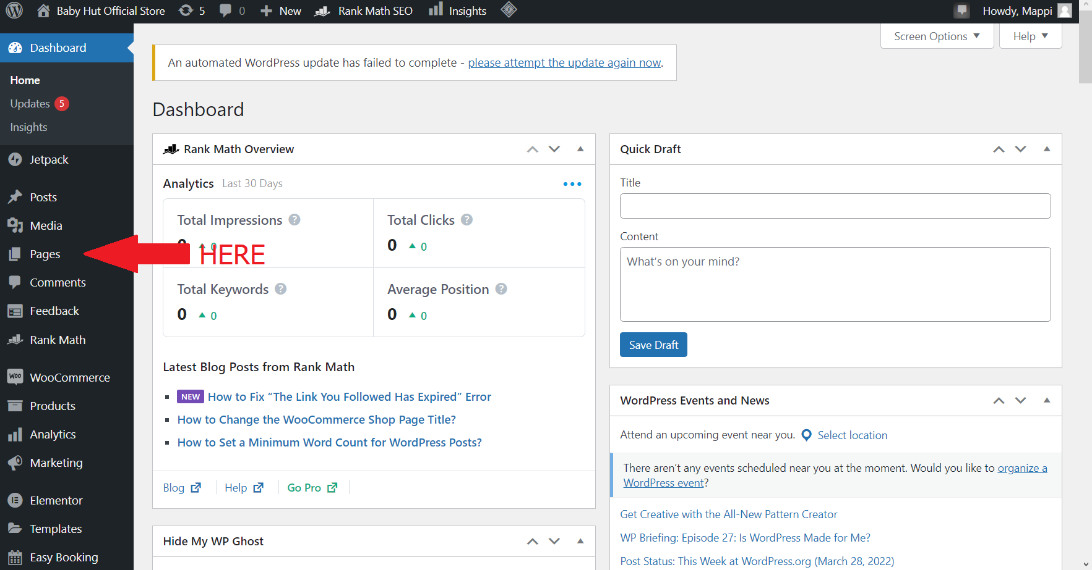

Capture 1. Location of “Pages” link on the Wordpress dashboard.

## 4.1. Add new page

After clicking on the “Pages” link, the website would lead you to the “Pages” dashboard, which allows you to see all the pages on the website.

To add a new page, simply click on the “Add new” button.

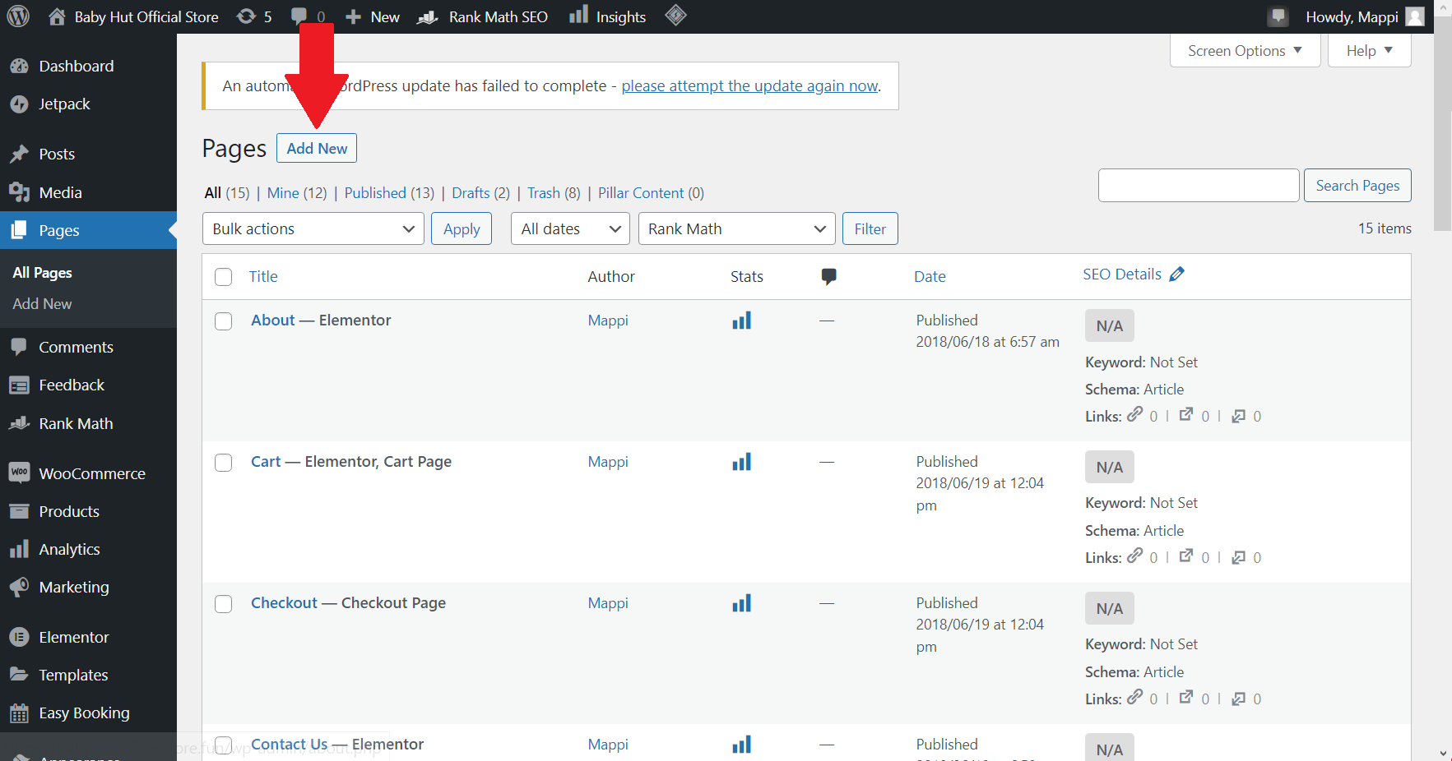

Capture 2 - Location of the "Add New" button.

This button will allow you to get access to a new page template. You can add any title and text you want in suitable places within the template.

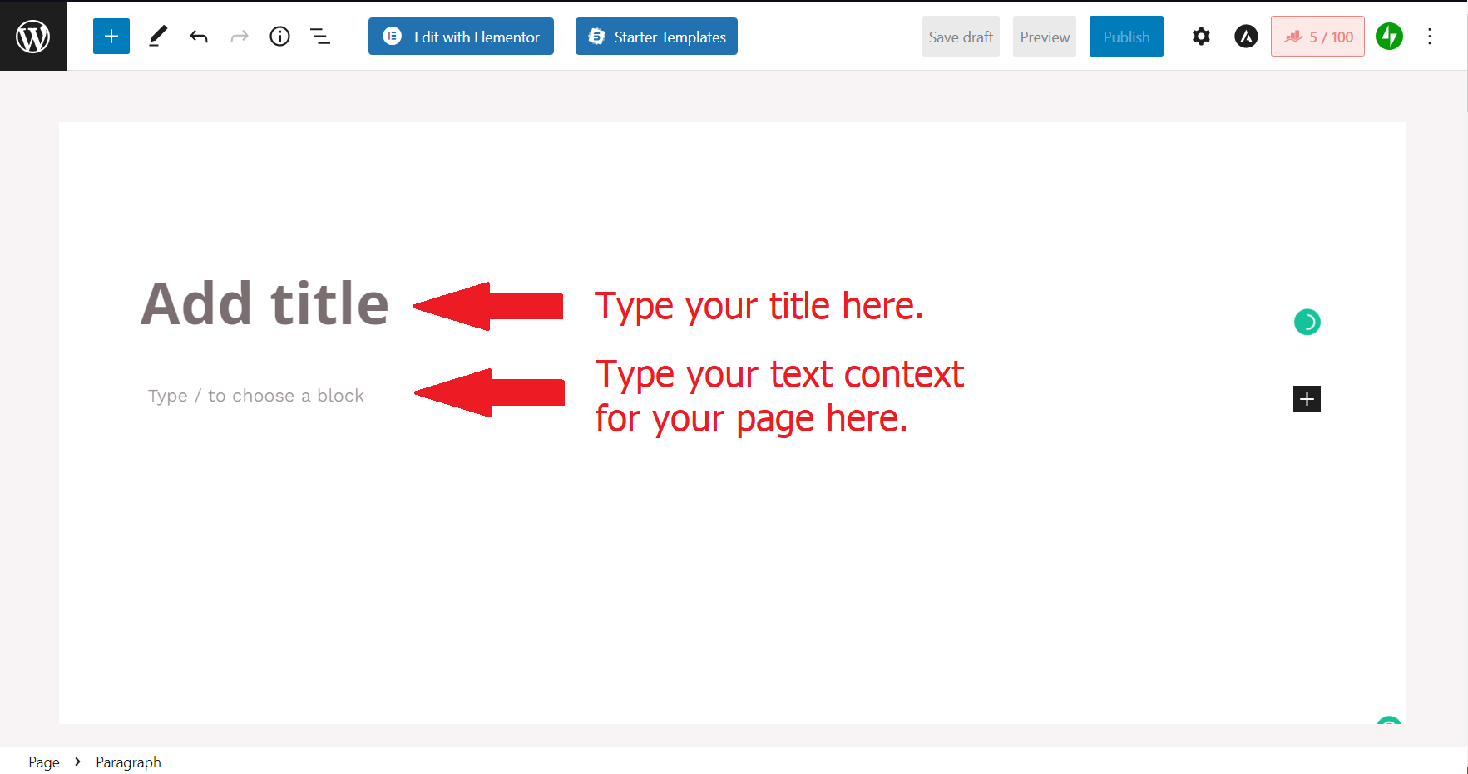

Capture 3 - Add title and text to the new page.

WordPress allows you to choose different kind of block for better customization. Press “/” would make the list below appear.

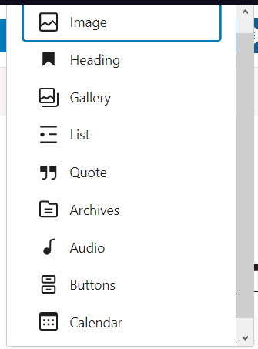

Capture 4 - Block list.

With this list, you can choose any type of block you want to add to the page. However, this is just a compact list. To show the full list of blocks, find a black squared button with a plus symbol like this  then click on “Browse all”. After that, a menu would appear on the left-hand side, allowing you to explore further kinds of blocks. This menu also provides another tab of “Pattern”, which is a built template that you can use for your page. The whole editing process would be drag and drop on the page to make it simple and user-friendly.

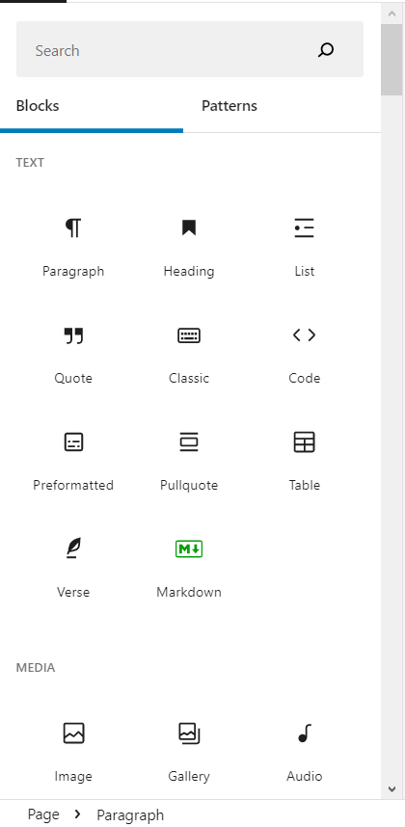

Capture 5 - Block menu

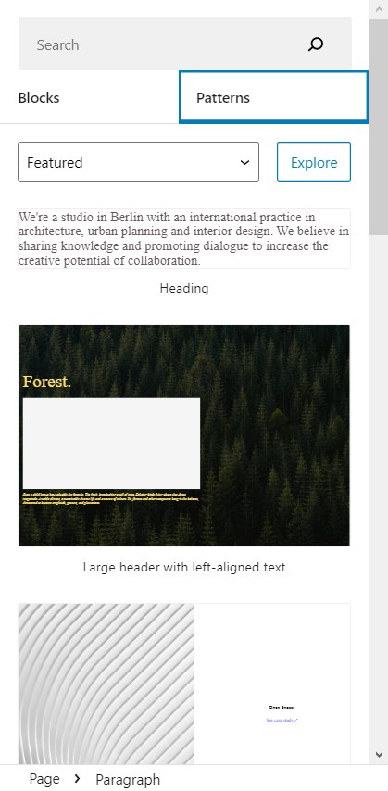

Capture 6 - Pattern menu.

Once you have finished filling in your desired content on the page, you can review your results by pressing the button “Preview” on the top navigation bar. If you are satisfied with the page, press “Publish” to save and publish your page. In case you are writing halfway or want to publish the page later, you can click on the “Save Draft” button to save what you have been working on.

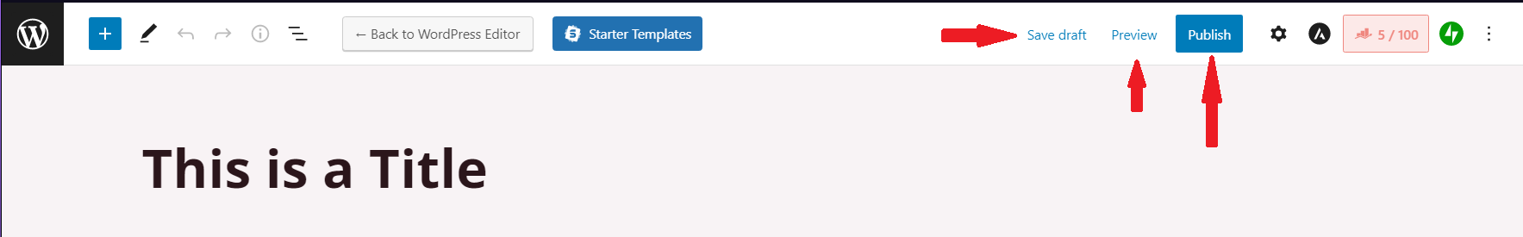

Capture 7 - "Preview", "Publish", "Save Draft" button location.

## 4.2. Add new page with “Elementor” plugin

In addition, to create new content with the WordPress default template, our team has installed a website builder plugin – “Elementor”. To use this plugin, simply click on “Edit with Elementor” on the new page template to get started.

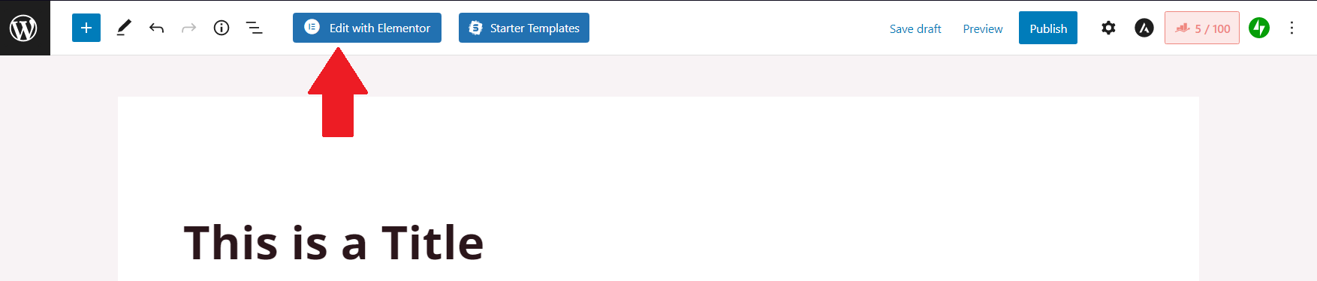

Capture 8 - Get started to edit page with Elementor.

The website should be redirected to the Elementor editing page. With this plugin, you can observe live previews while building up content. The other steps of creating a new page are the same with WordPress builder, simply drop and drag any elements from the left-hand menu.

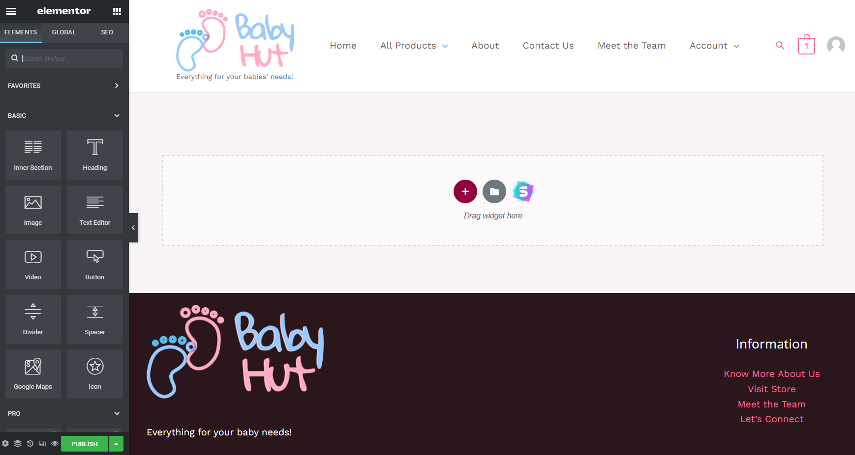

Capture 9 - Elementor editing platform.

When finishing editing, make sure to click the “Publish” button. Without any clicking, the page would not be saved. After saving, you would be redirected back to the WordPress template and have a choice to publish the page or not.

## 4.3. Page settings

After publishing a page, it will appear on the list when you click on the “Pages” link.

To make sure that the page appears in the right menu, you need to edit the menu location of the page. Hover on your page and click on “Quick Edit”.

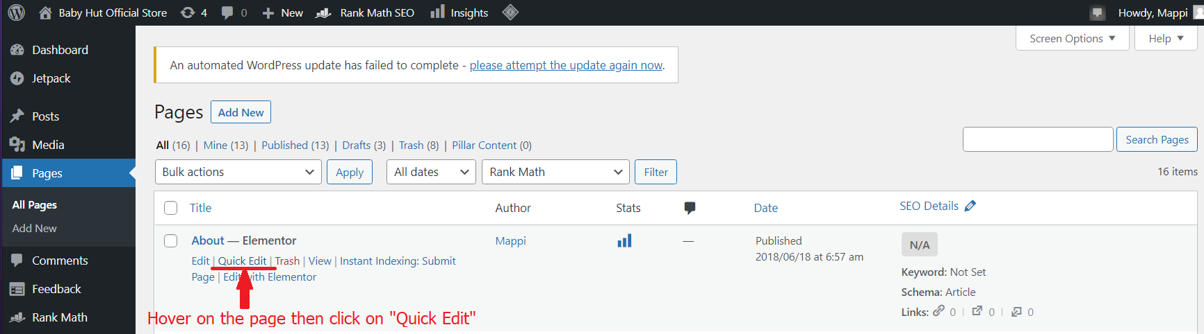

Capture 10 - "Quick Edit" location.

Then click on the Parent section and pick the right location for your page.

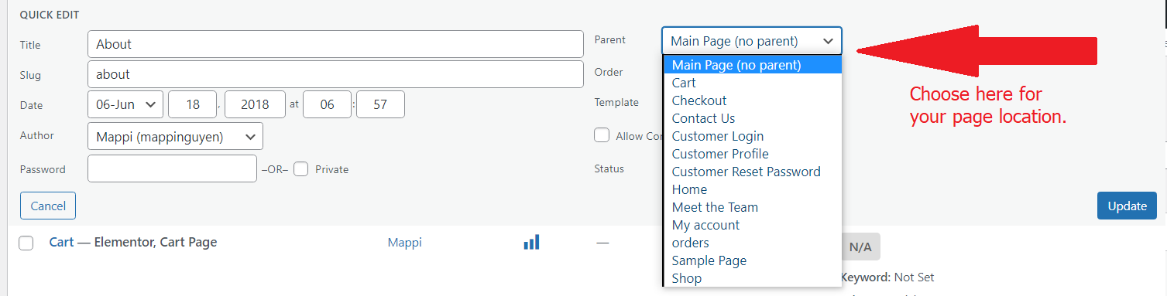

Capture 11 - Page's parent settings.

For example, if you want your new page to appear under any other pages, then you can choose that page to be the parent for your page. If your page has no parent, you should choose the “Main Page (no parent)” option as to be shown in the capture above.

This “Quick Edit” section also allows you to customize other attributes of the page: title, date and time, author, password,… Moreover, it can be used to see whether the page is pending or published and what template has been chosen.

## 4.4. View new page

There are two ways to view your new page.

The first option is to access the website like any other visitor then uses the navigation bar to select the page. Putting the page’s URL in the navigation bar of the browser is also a direct way.

The second option is to view your page from the admin dashboard. To do this, hover over the page you want to access in the “Pages” link. A “View” link would appear. Click on that and you should be able to view your page.

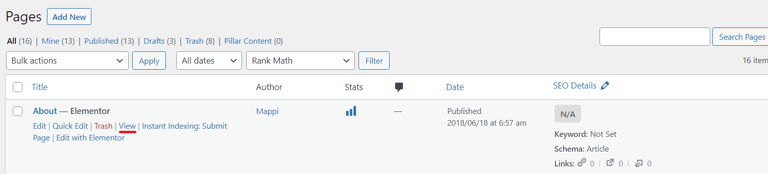

Capture 12 - "View" link.

## 4.5. Update existing web page

To update any created page, simply hover over the page and click on “Edit” as shown in the capture below.

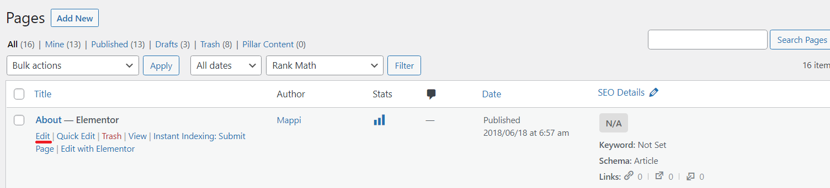

Capture 13 - "Edit" link.

A page editor would appear similar to when you first create a new page. Do your editing on that editor and make sure to “Save Draft” or “Publish” when you are done to save your work.

## 4.6. Remove a page

To remove a page, simply hover over the page and click on “Trash” as shown in the capture below. This would put your page on the “Trash” list.

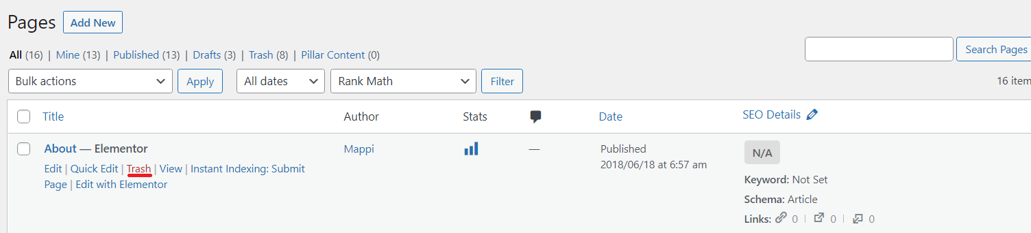

Capture 14 - "Trash" link.

Alternatively, you can tick the box on the left of the page’s title then choose “Move to trash” at the “Bulk action” list. After that, click on the “Apply” button, and your page would be on the “Trash” list. This also helps to remove several pages at the same time.

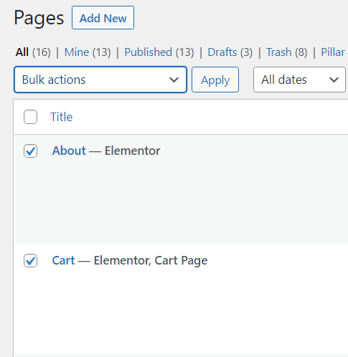

Capture 15 - Tick on the page(s) you wished to remove.

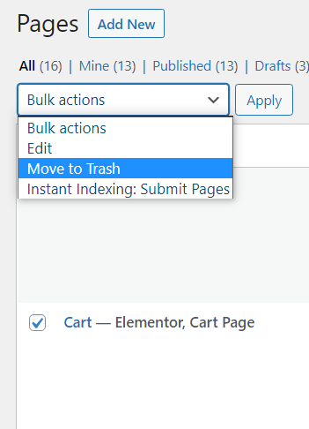

Capture 16 - Choose "Move to trash" in "Bulk actions" list then click "Apply".

To remove any page permanently, go to the “Trash” list by clicking on the “Trash” list. Hover on any page you wish to delete then click “Delete Permanently”. You can also tick on the box next to the title for mass page deletion. Additionally, if you want to delete all the trash pages, you can just click on the “Empty Trash” button.

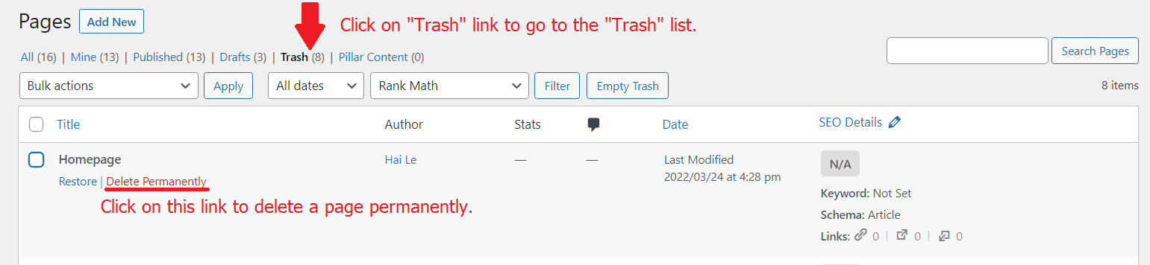

Capture 17 - "Trash" link and "Delete Permanently" link location.

If you want to restore any page that has been put into the “Trash” list, simply hover over the page then click on “Restore”. **Note:** You can not restore a page that has been deleted permanently.

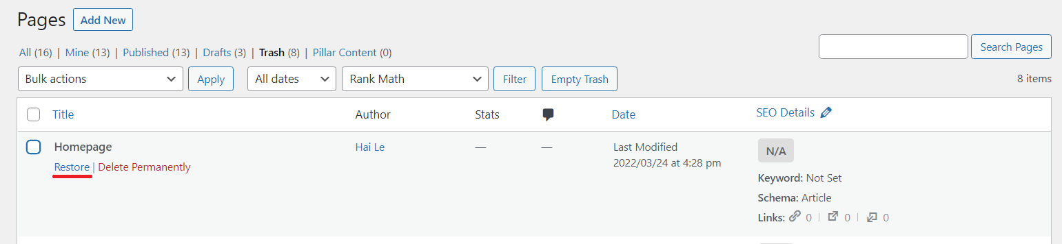

Capture 18 - "Restore" link.

# 5. Managing the gallery

To access the media library of the website, click on the “Media” link on the left menu of the dashboard as shown below.

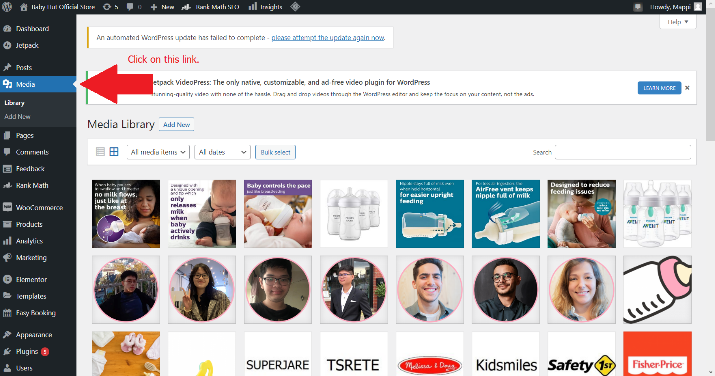

Capture 19 - "Media" link location.

## 5.1. Adding image to gallery

To add any new image to the media library, click on the “Add New” button. The file upload section would then appear, allowing you to drop any images to upload or click on the “Select Files” button to select files from your computer.

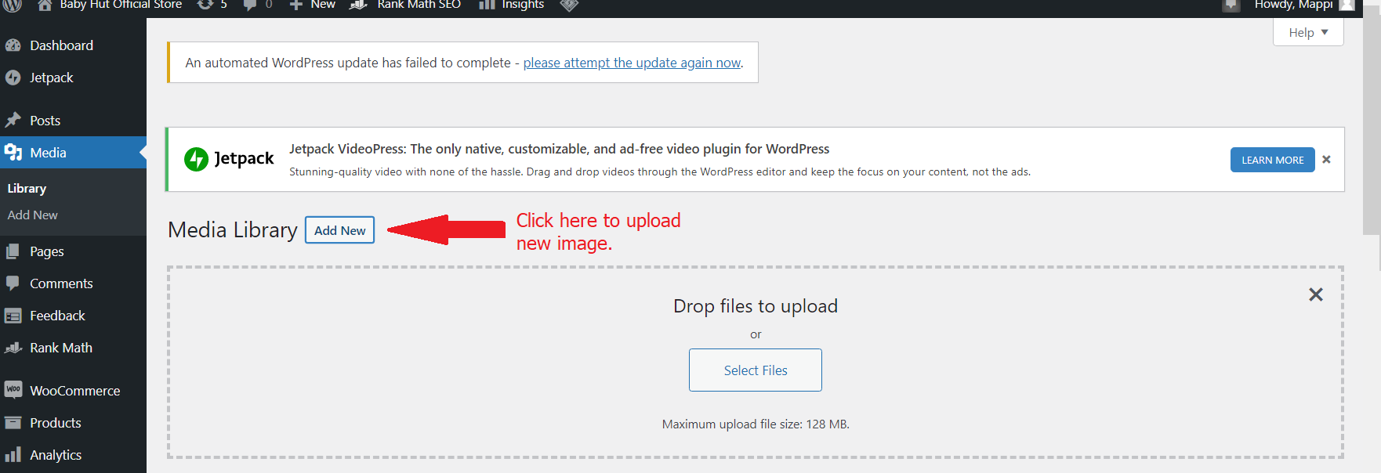

Capture 20 - "Add new" button location and file upload section.

## 5.2. View and update image in the gallery

Viewing an image would be similar to viewing a page as guided above. Simply click on any image you want to view to check on that image.

To update an image, hover on the image and select “Edit”.

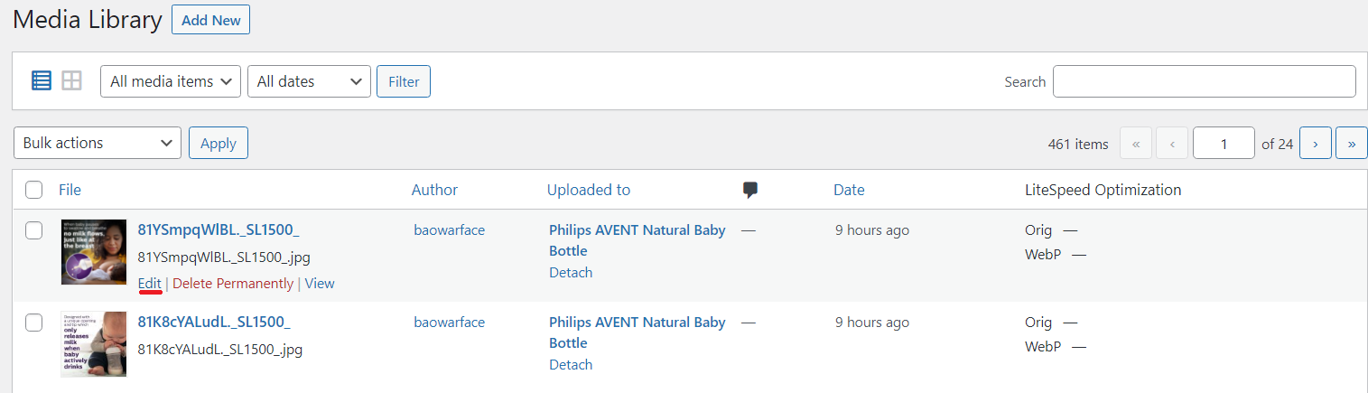

Capture 21 - "Edit" link.

## 5.3. Delete an image from the gallery

Click on “Delete Permanently” or tick on the box and select bulk action to delete an image.

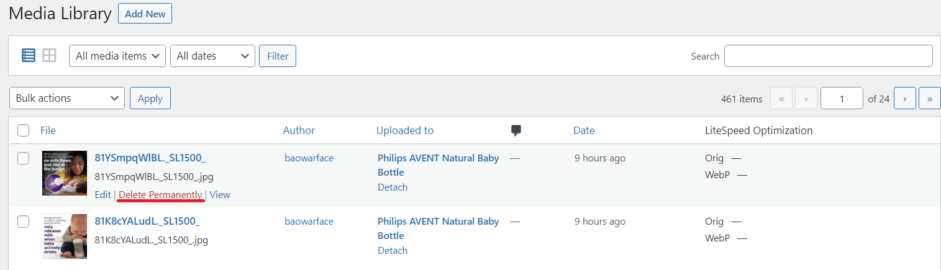

Capture 22 - "Delete Permanently" link.

# 6. Managing customers

Customers' information is stored under the plugin “WooCommerce”. As such, to manage customers, we will work with this plugin. First, click on the “WooCommerce” link on the left-hand side menu.

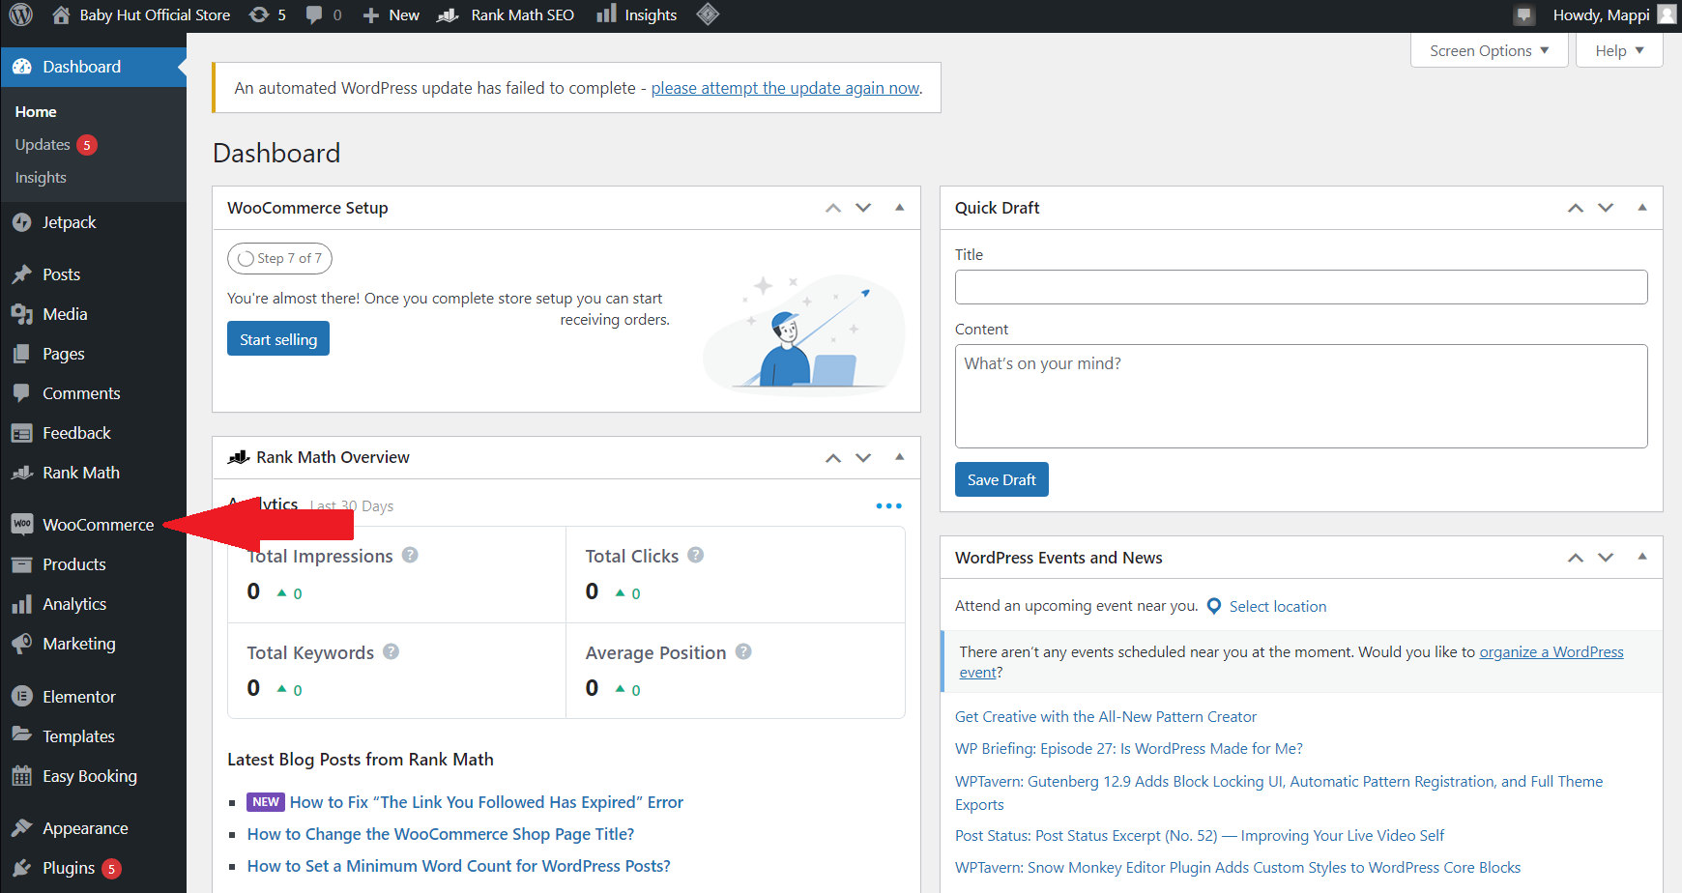

Capture 23 - "WooCommerce" link location on the menu.

To access the “Customer” link of WooCommerce, hover over the WooCommerce link then click on “Customer”.

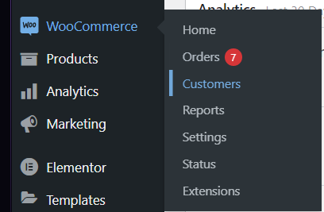

Capture 24 - How to access "Customers" link of WooCommerce.

All the customers that have signed up in the website would appear in the list of “Customers”.

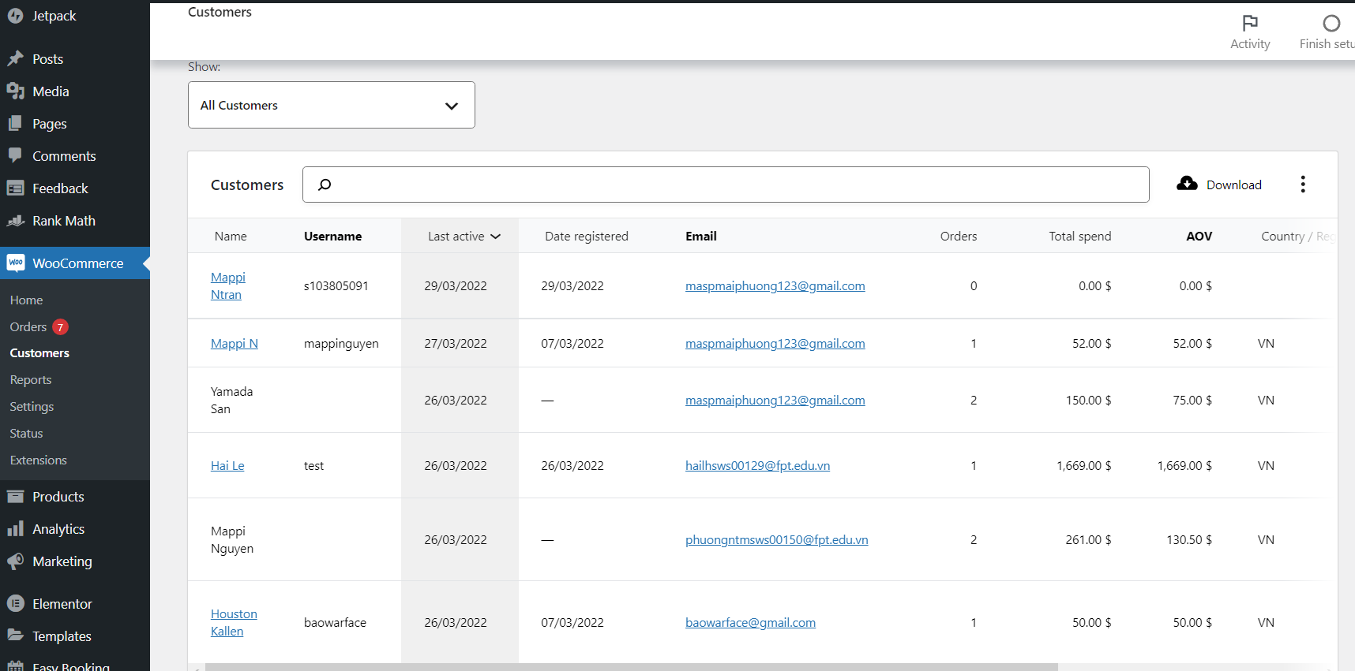

Capture 25 - "Customers" link dashboard.

## 6.1. Add a new customer

There are two ways to add a new customer. The first option is for the customers to register themselves by using the signup page of the website. The other option is for the admin to register a user manually. To do this, you have to go to the “Users” link. Scroll down the dashboard to allow the left-hand menu to show more links, then click on “Users”.

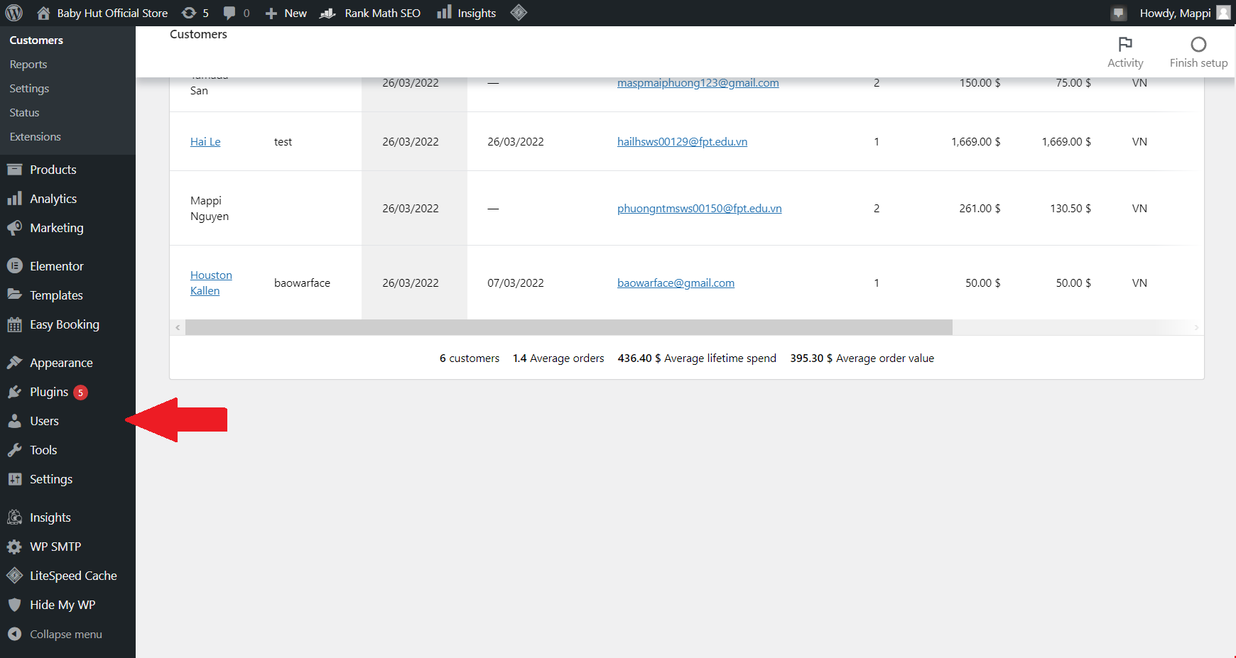

Capture 26 - "Users" link location.

The user's link then would be shown. To assign a new customer, click on the “Add new” button next to the title of the link.

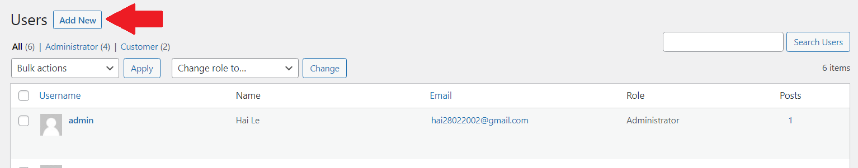

Capture 27 - "Add New" button location.

Once you have clicked on the button, a form would be shown to manually type in the user’s information. In this case, we are adding a new customer. Therefore, the role of this user is “Customer”. Note: If you choose another role for this user, they would not appear in the customer list.

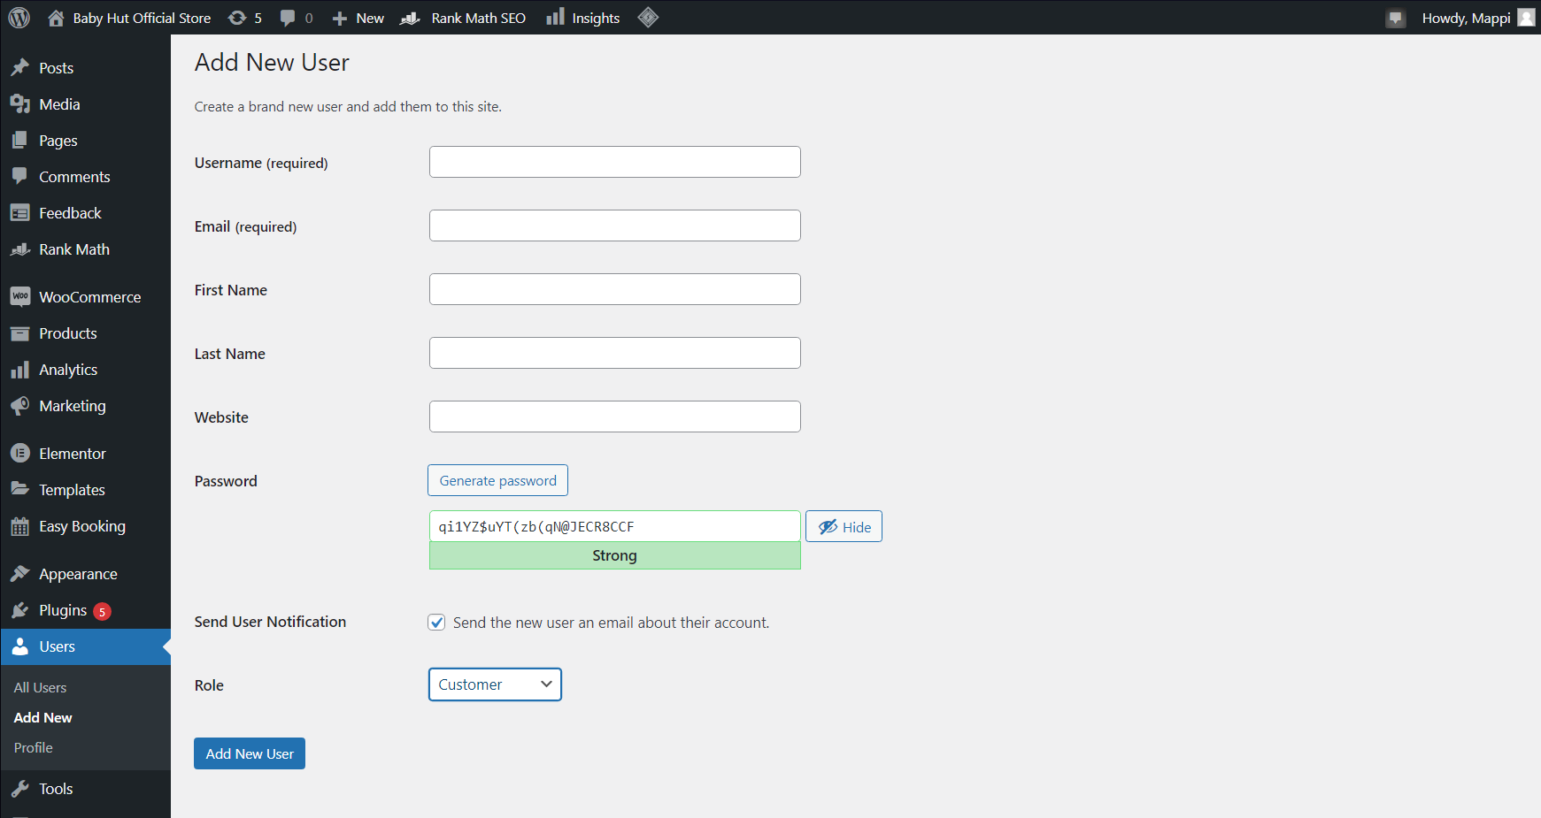

Capture 28 - Form to assign new customer.

After filling in all the required information, press the “Add New User” button at the bottom to complete registering a new customer.

## 6.2. View customer

To see all of your customers, go back to the “Customer” link as guided above. The list should be shown with attribute columns of customers.

To view an individual customer, click on their name. A user editor would then be shown all of their information. Note: You can only view a customer who has registered their account on the website. For customers who did not sign up for accounts, their information is shown on the customers’ table.

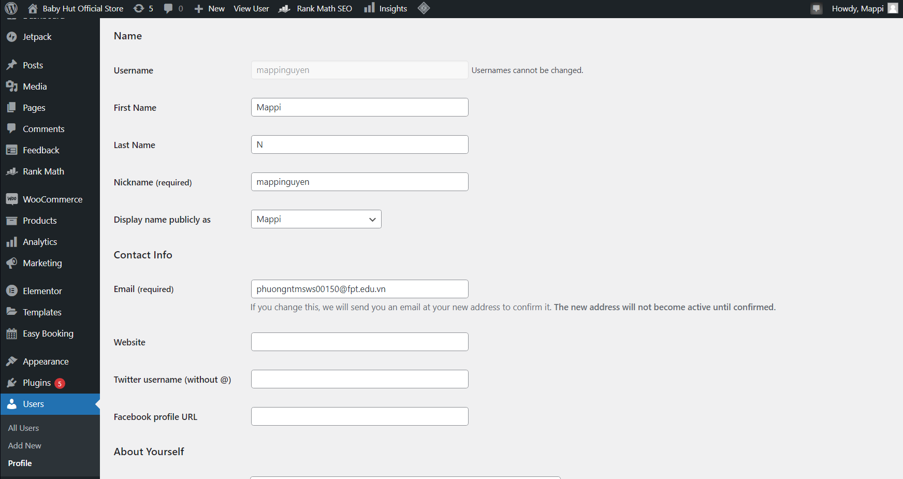

Capture 29 – A customer profile example.

## 6.3. Update a customer

After clicking on a customer’s name, you would be redirected to the edit user page. On this page, you can customize almost every piece of information about your customer, except for their username. This page consists of personal information such as name, role, contact information, and addresses. There is also an account management section that would help you to assign a new password for your customer.

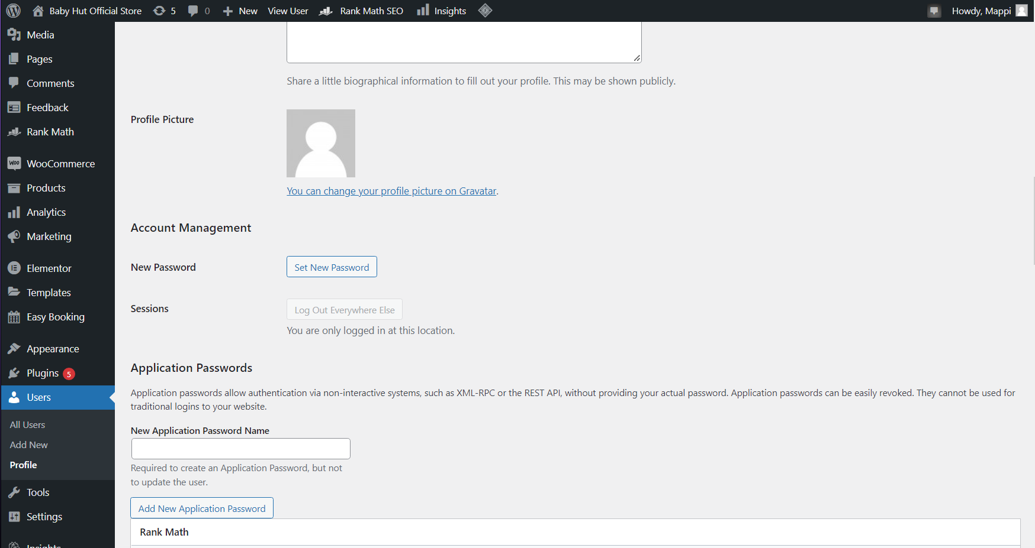

Capture 30 - "Account Management" section in a customer profile.

After updating new customer data, make sure to click on the “Update Profile” button at the bottom of the page.

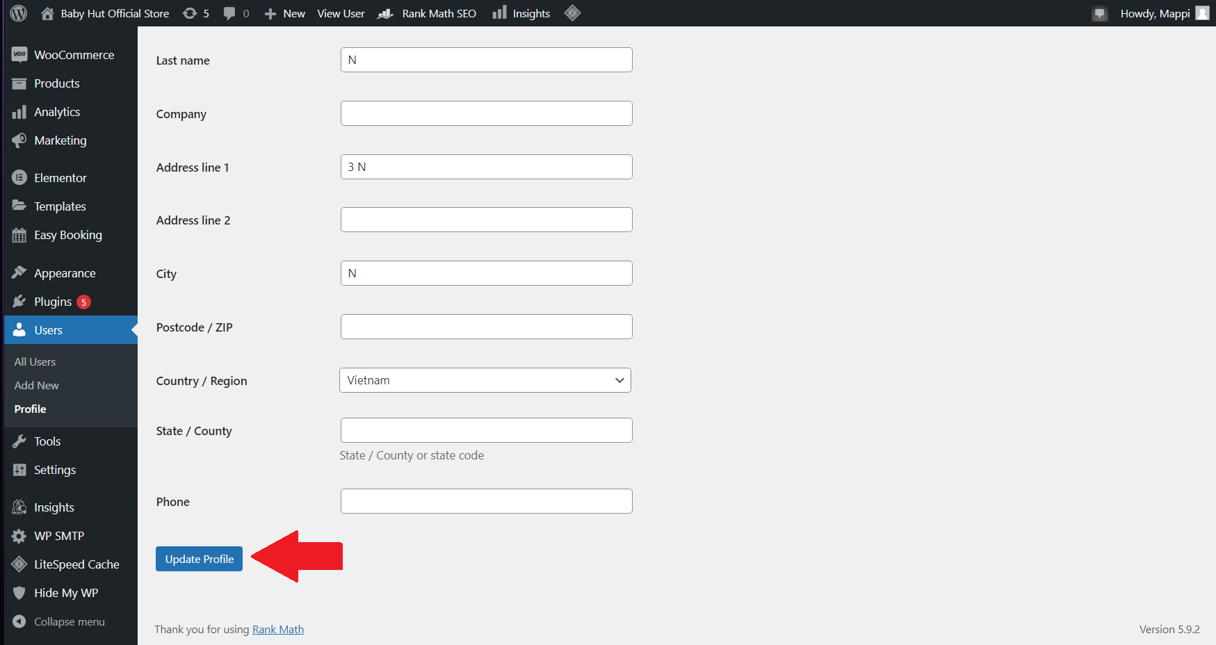

Capture 31 - "Update Profile" button location.

## 6.4. Delete a customer

To delete a customer, firstly you have to go to the “Users” link. After that, find your customer user name then hover over it, click on “Delete” and they would be gone.



Capture 32 - How to delete a customer.

For customers who didn’t sign up for accounts, they are considered guest users. Therefore, they cannot be deleted but their information cannot be updated either.

## 6.5. Sort customers by category

Customers can be sorted using advanced filters. To do this, click on the list beneath the “Show:” characters on the “Customers” page, then choose “Advanced Filter”.

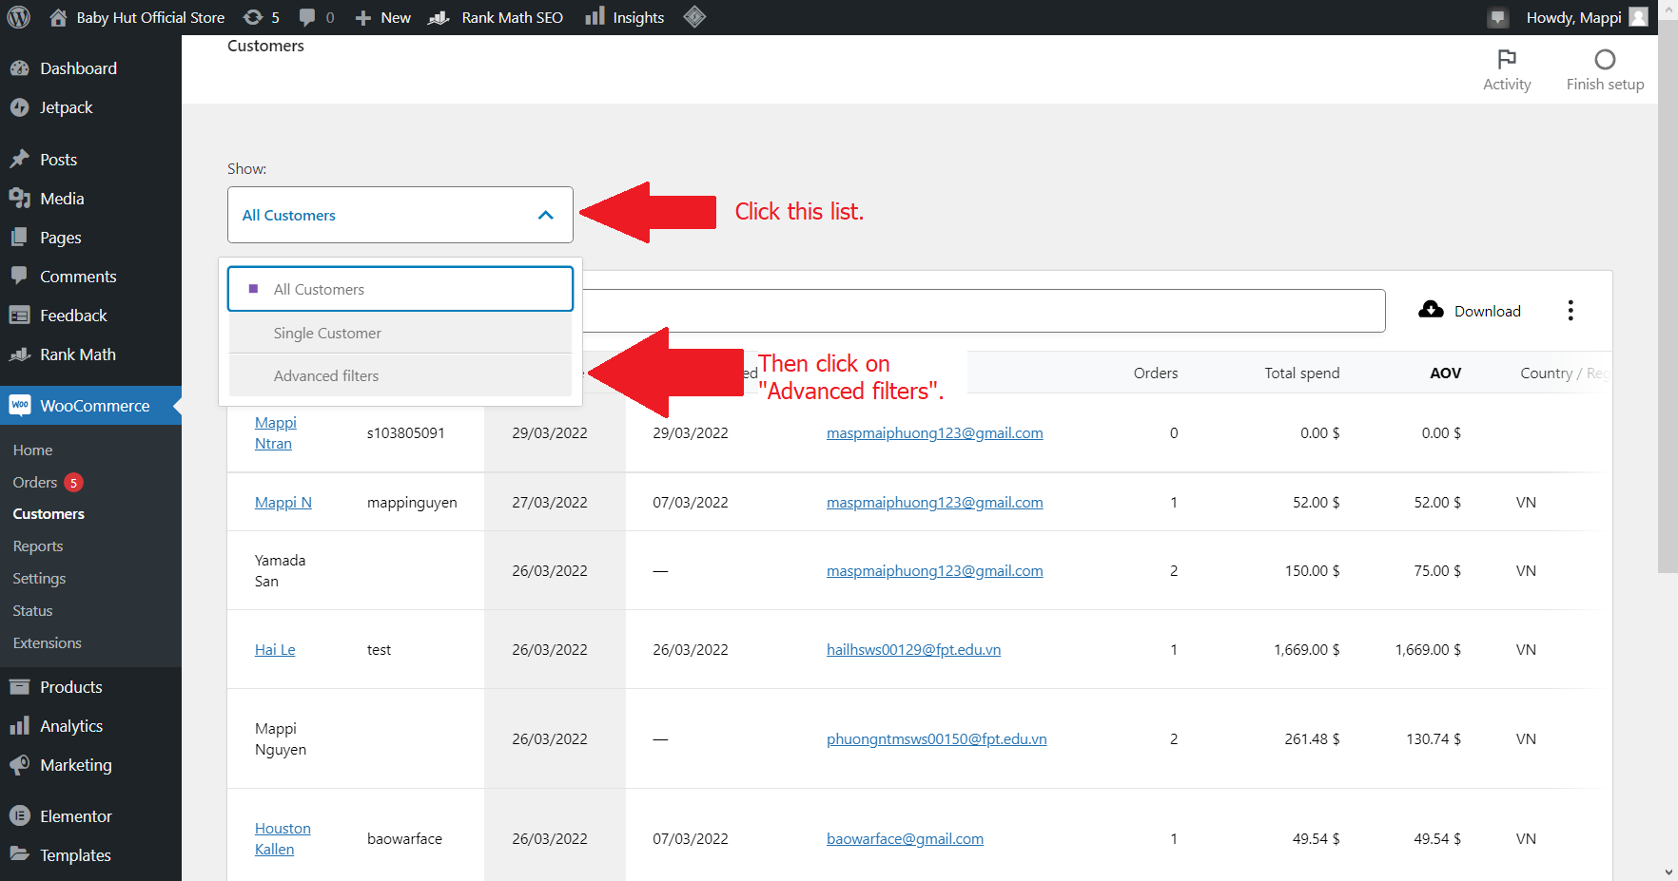

Capture 33 - Get started to the "Advanced Filters" option.

After that, a section would be shown. There are many customizations for you to sort your customer list in your desired way.

First of all, you can choose to show customers match all or any of the filters you choose.

Secondly, you can click on the “Add a Filter” to choose any categories you want. Different categories would have different ways to customize, helping you to optimize your sort.

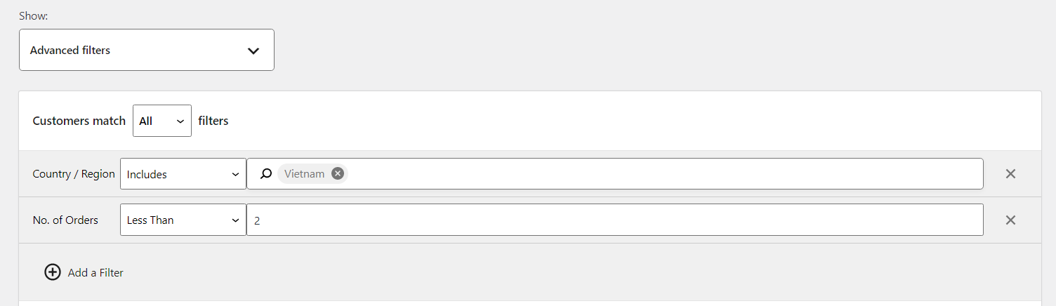

Capture 34 - An advanced filters using example.

Once you finished choosing your filters, click on the “Filter” button to sort the customers. The table beneath would then change to match your filters. To make the table return to the original one, simply choose “All customers” from the list or click on “Clear all filters” if you want to try another filter option.

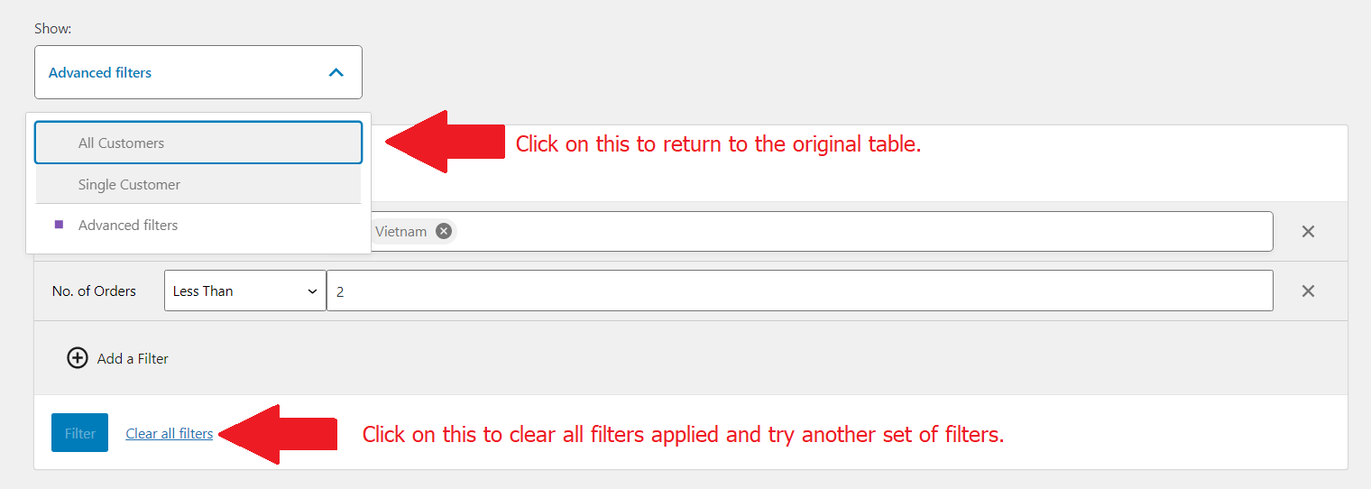

Capture 35 - Further options for sorting section.

## 6.6. Add contact us section for customers.

To help customers know how to contact with the company, a “Contact us” section should be built. Our team have worked on this, so there’s already a “Contact us” page. In case you want to create a completely new one, just follow the step of “Add new page” above in Section 4.

To access the page, go to “Pages” link. Then click on “Contact Us” page.

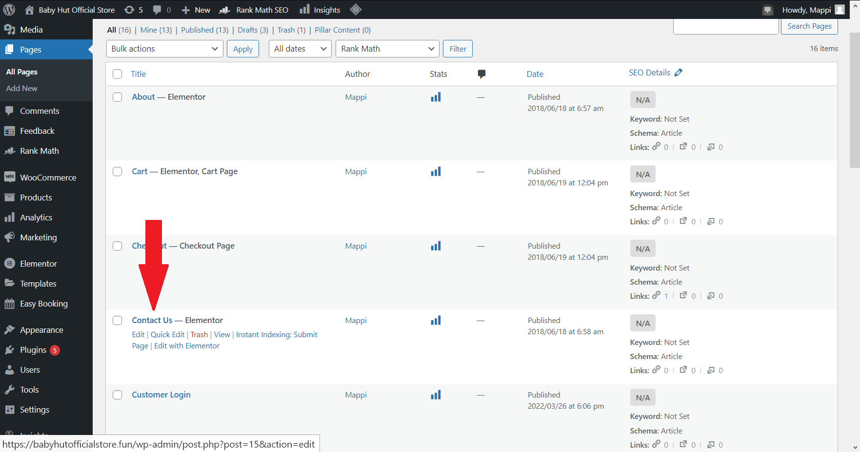

Capture 36 - Location of "Contact Us" page.

## 6.7. Edit contact us section.

The “Contact Us” page built by our team is created by Elementor. As such, you have to click on “Edit with Elementor” to edit any information on the page.

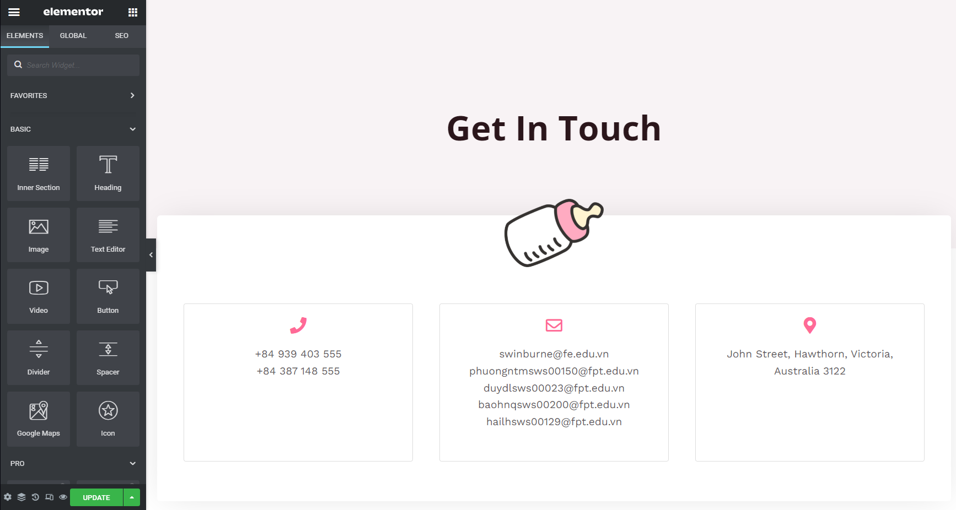

Capture 37 - Elementor editor with "Contact Us" page.

After accessing Elementor, freely customize the “Contact Us” section, then click on the “Update” button to save all your customization.

# 7. Using social media with the website.

## 7.1. Using social media for business.

Social media is a crucial part of human lives. Therefore, it is essential for businesses to use social media as a way to communicate with their customers. As such, our team has created accounts on these three popular social media: Facebook, Twitter, and Instagram. The links to the social media account can be found in the footer of the website.

To change the linking, go to the site while login into the admin user. Then click on “Customize” on the top bar.

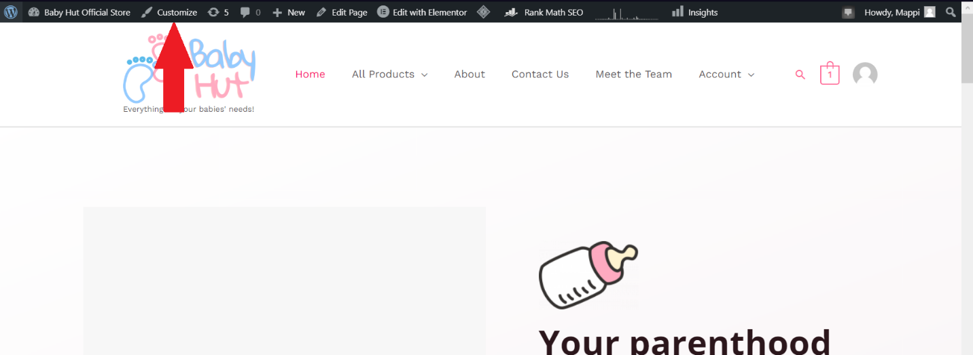

Capture 38 - "Customize" link location.

A left-hand menu would then appear, allowing you to customize this site. Click on “Footer Builder” to access the footer editor.

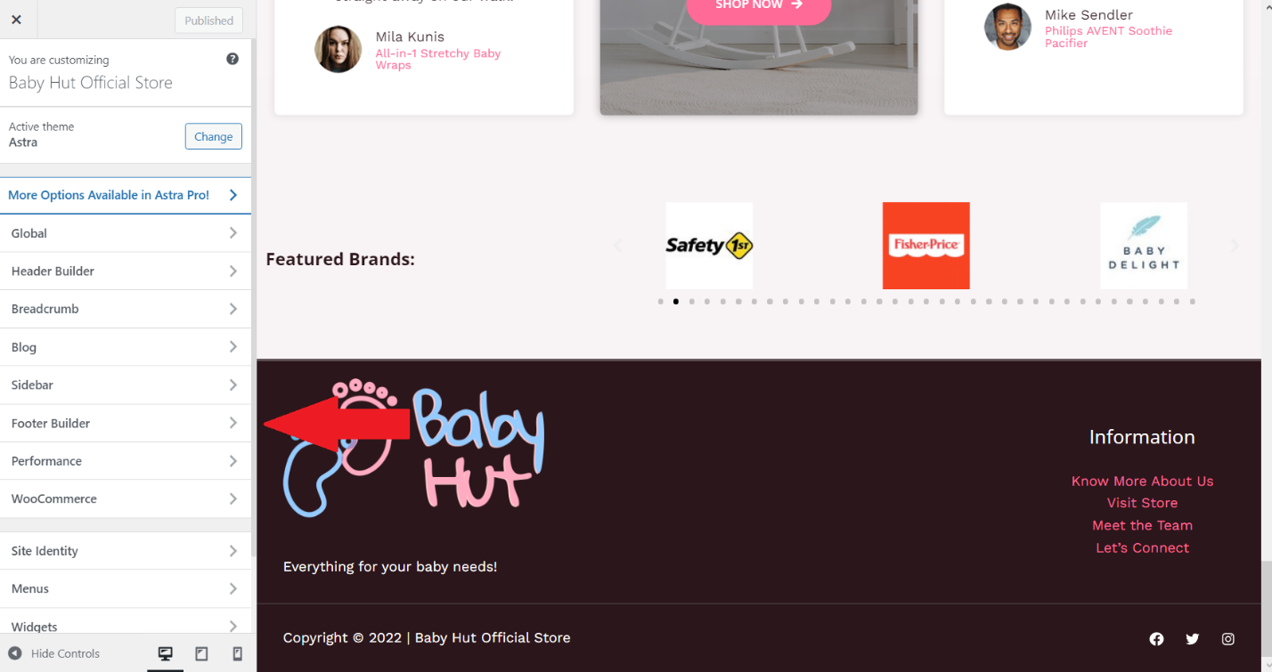

Capture 39 - "Footer Builder" location.

After that, click on “Social” section.

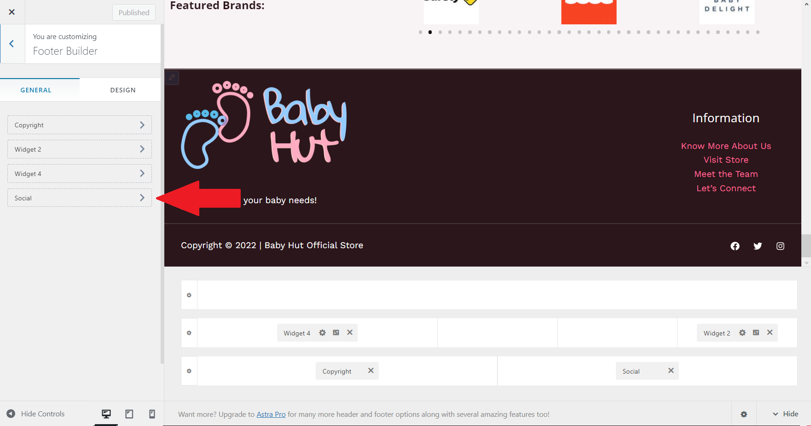

Capture 40 - "Social" section location.

Once you have clicked on the “Social” section, you would see three social media icons. Click on any icon you want to change the linking. A box would be shown to update new information.

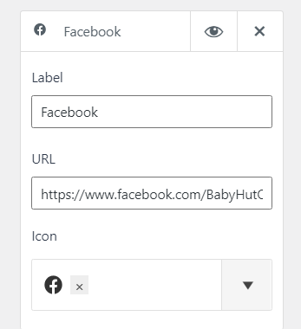

Capture 41 - Customizing the linking of social media.

You can also add new social media by choosing the social media name then clicking on the “Add Social Media” button.

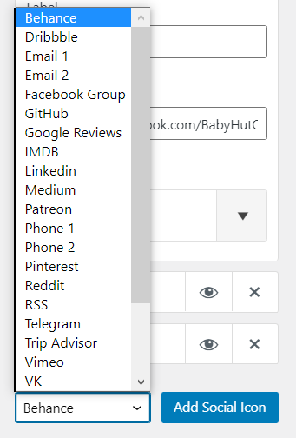

Capture 42 - Adding new social media.

After customizing, make sure to click on the “Publish” button at the top of the menu to save all changes.

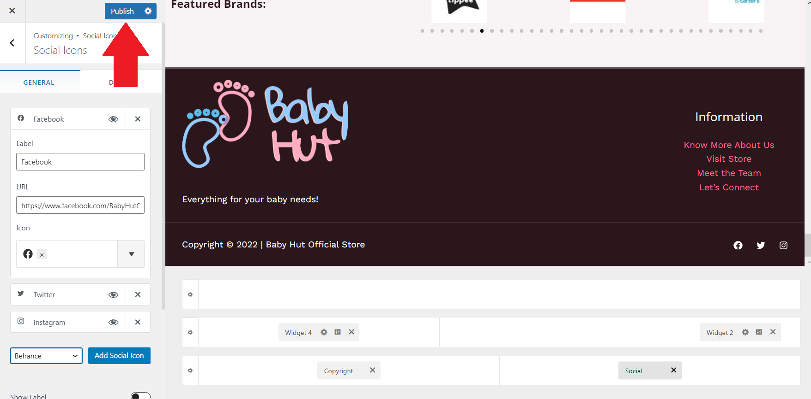

Capture 43 - "Publish" button location.

# 8. Managing the web store.

To manage the online store, we will use the “Products” link that can be shown on the left-hand menu.

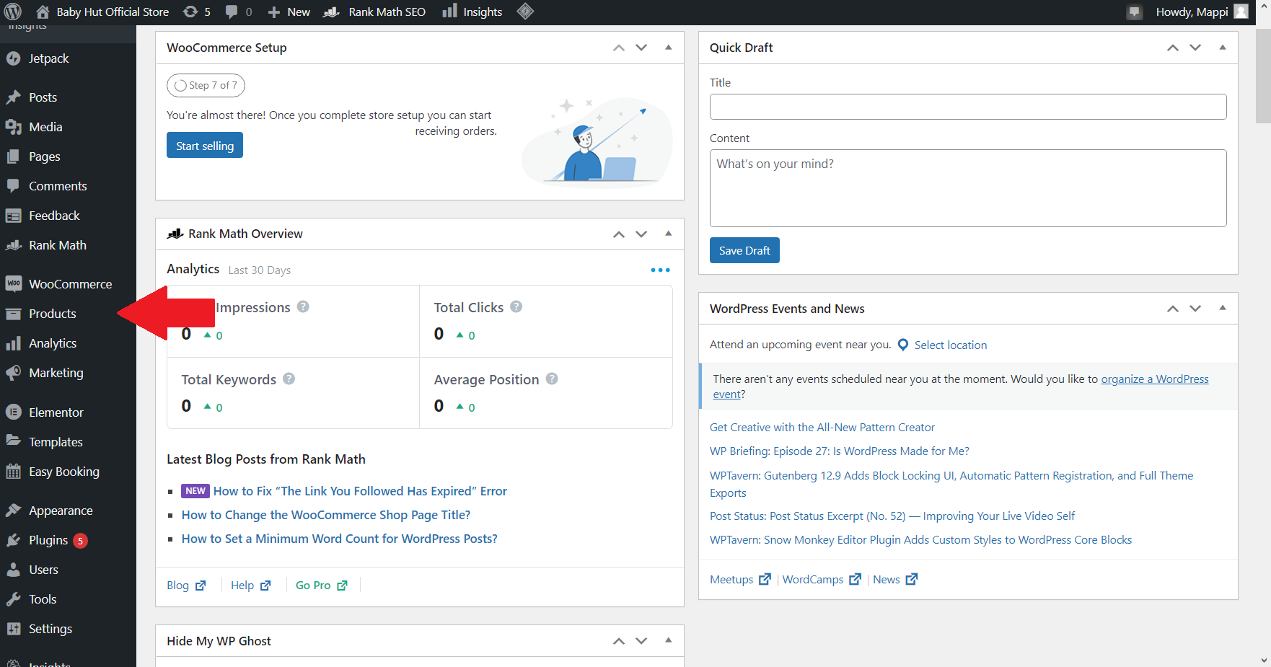

Capture 44 - "Products" link location.

## 8.1. Adding product categories.

Hover on the “Products” link then choose the “Categories” that appear on the small menu.

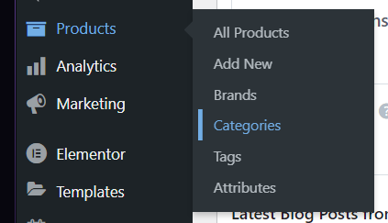

Capture 45 - "Categories" location.

The “Product Categories” page should be shown after clicking on “Categories”. A category list has been created.

To add a new category, simply fill in the information in the left form, then press “Add new category”. **Importance:** Be sure to choose the right parent in the “Parent category” list for an organized category list.

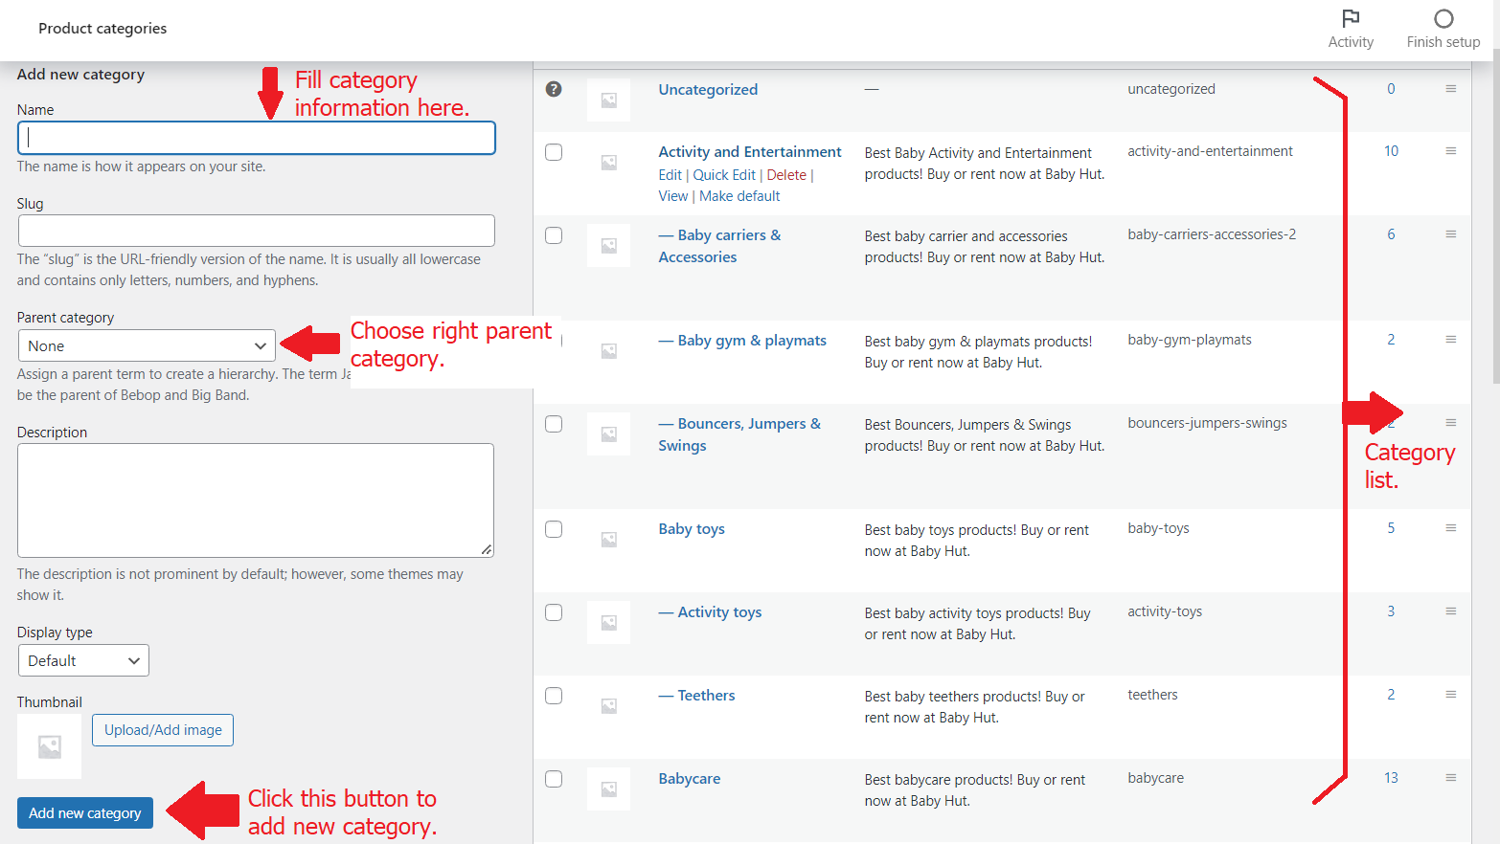

Capture 46 - Adding new category process.

8.2. Adding product brands.

On the “Products” menu, click on “Brands”.

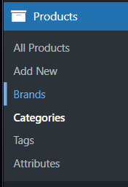

Capture 47 - "Brands" location.

The page should then be redirected to “Brands” page, which is similar to “Categories” page above. On the right of the screen, there is a brand list that have been created. To add a new brand, fill in the information in the form on the left of the screen. Make sure to add a brand logo, then click on “Add New Brand” to add a new brand.

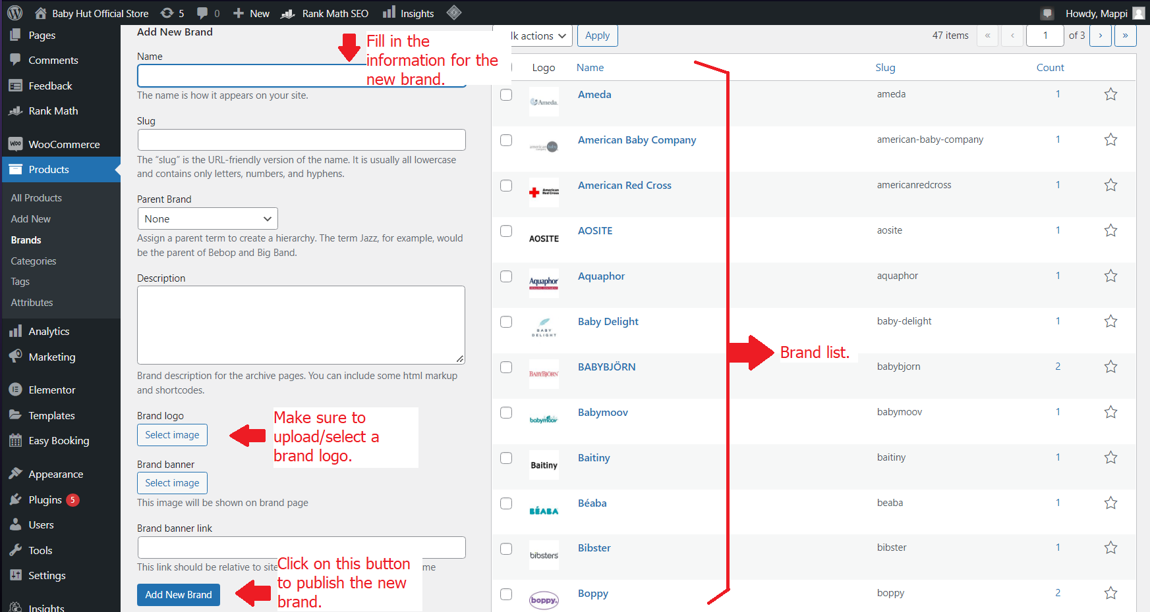

Capture 48 - Adding new brand process.

## 8.3. Adding products.

On the “Products” menu, click on “Add new” to add new product.

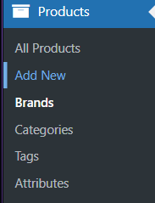

Capture 49 - "Add New" location.

A new page for a new product should be shown, letting you fill in details of this product.

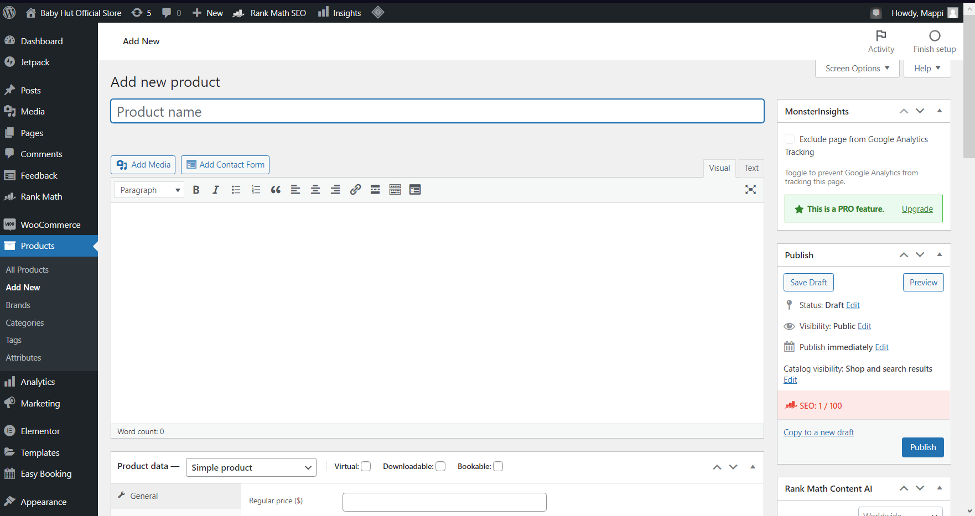

Capture 50 - Add new product template.

The large white box under the Product name is the Description for the product. In this box, you need to write the content for your product. There is a simple editor bar on the top to assist you with styling.

Scroll down a bit then you will see the “Product data” section. This section helps to assign the Booking feature to rentable products as well as also products to have variations.

If the product is a simple one without any variations or rental features, you don’t need to do anything but fill in product data. Type in the price and shipping data for the product then go to the next section.

If the product doesn’t have a rental feature but has variations e.g. different colors, you need to follow these steps:

Step 1: Click on the list next to the “Product Data” character then change the product type to “Variable Product”.

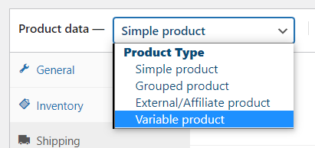

Capture 51 - Product type list.

Step 2: Click on “Attributes”. Choose “Color” from the list of Attributes, then click on “Add”.

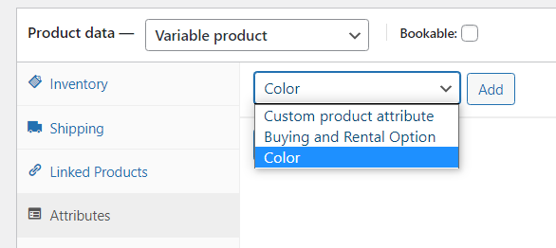

Capture 52 - Attribute list.

Step 3: Choose any values you want to include in the product from the list of values. Tick on the “Used for variations” box. After that, click on the “Save attributes” button.

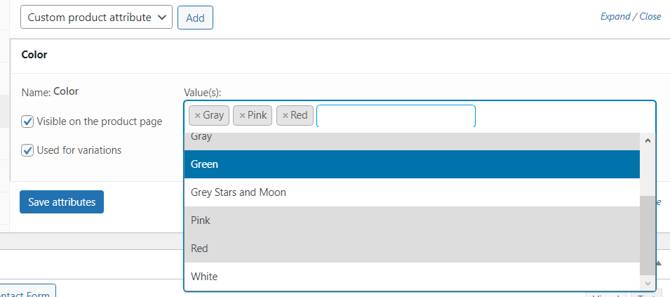

Capture 53 - Adding attribute and values process.

Step 4: Click on the “Variations” section. From the list, choose “Create variations from all attributes” then click the “Go” button. Click “OK” with any pop-up window from the browser.

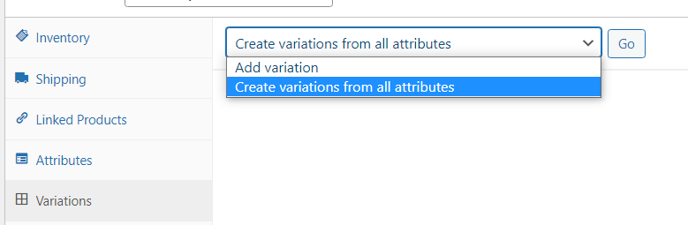

Capture 54 - List to create variations.

Step 5: All variations would then be added to the product. Make sure to fill in information such as price, shipping data to make the variation works.

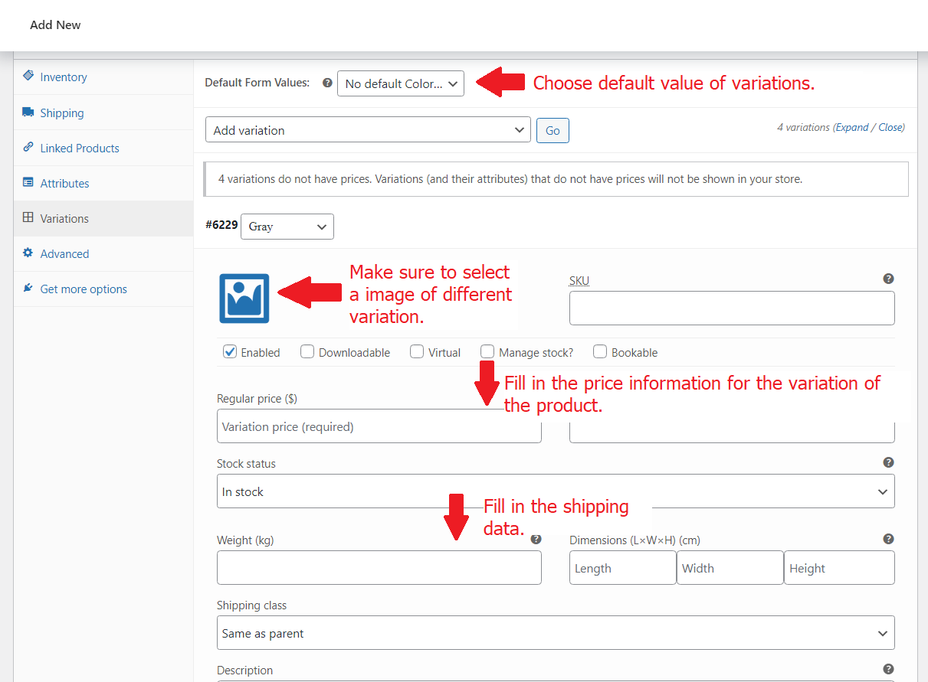

Capture 55 - Variations information adding process.

Step 6: After completing filling in information for all variations, click on the “Save Changes” button to save all of your work. Make sure to click this button right away as changes would be gone otherwise.

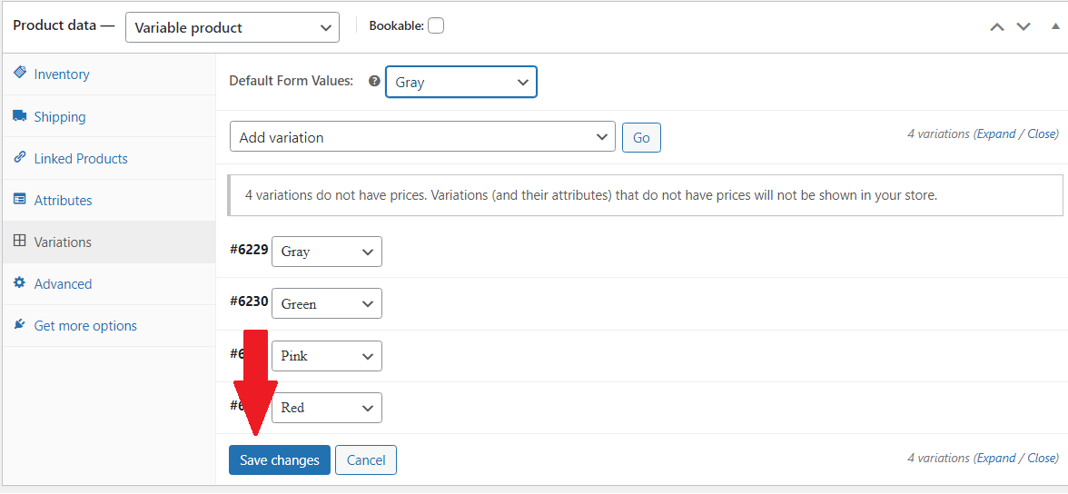

Capture 56 - "Save changes" button location.

If the product is rentable, do the following steps:

Step 1: Click on the list next to the “Product Data” character then change the product type to “Variable Product”. (See Capture 51 for reference)

Step 2: Click on “Attributes”. Choose “Buying and Rental Options” from the list of Attributes, then click on “Add”. (See Capture 52 for reference)

Step 3: Click “Select all” to include all values from the attribute, then click “Save attributes”.

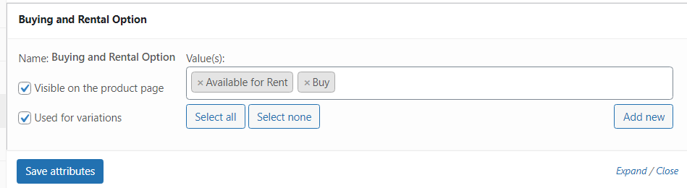

Capture 57 - Attribute values selecting.

Step 4: Click on the “Variations” section. From the list, choose “Create variations from all attributes” then click the “Go” button. Click “OK” with any pop-up window from the browser. (See Capture 54 for reference)

Step 5: Filled in the information for two different variations: rent and buy. The step of filling in information would be the same when adding information for different color variations, but the price of the rental option would be calculated by dividing the buying price by 365. (See Capture 55 for reference)

Step 6: After completing filling in the information, tick on the box “Bookable” for the product, then tick on the box “Bookable” in the variation “Available for Rent”. This would allow the plugin “Easy Booking” to work correctly to show the Rental option on the products and allow visitors to choose the rental date period.

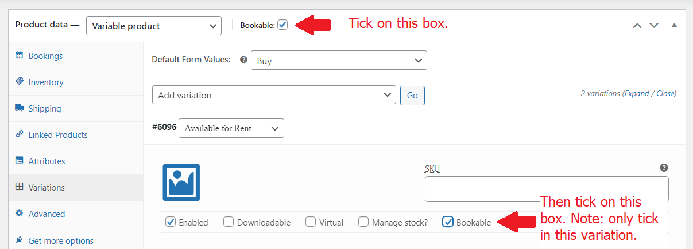

Capture 58 - Adding booking/rental feature for rentable product.

If your product is both rental and has various color variations, make sure to do all the steps above. Your variations would look like the capture below:

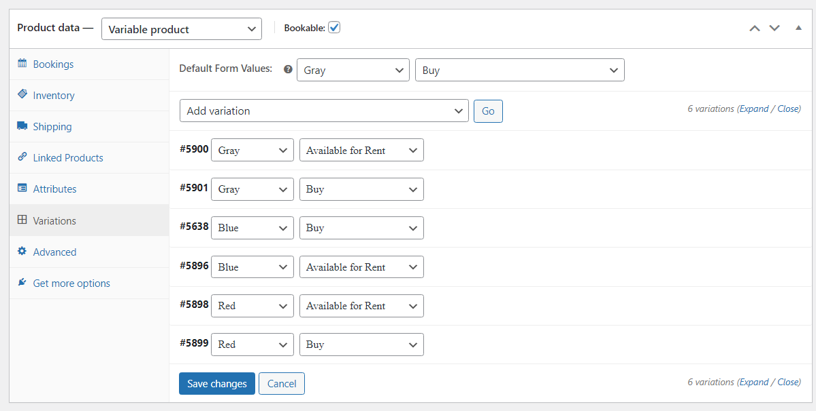

Capture 59 - Example for product with both rental and color variations.

After completing the product data, you should proceed to edit the Short Description of the product. The short description is what is shown when your product pops up on the search result. As such, it is very important to write an interesting short description to attract customers.

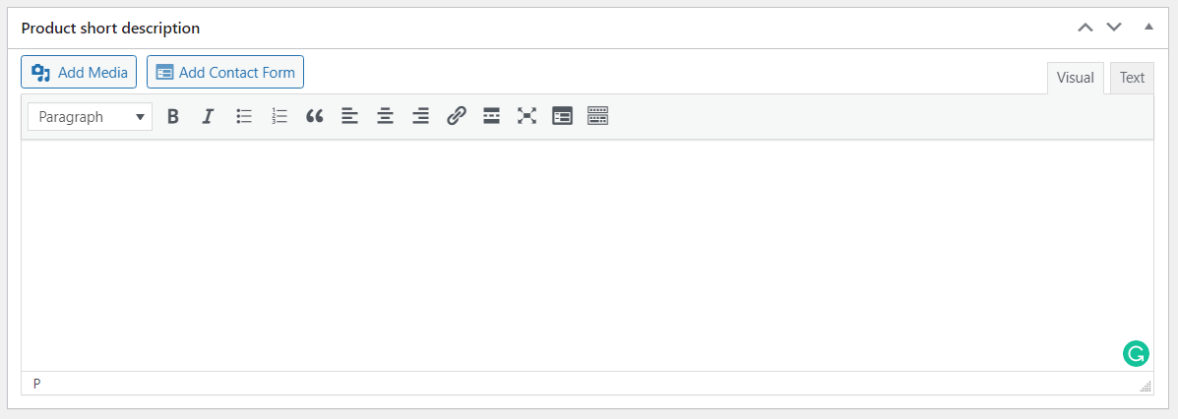

Capture 60 - Short Description Editor.

On the right hand of the short description, there is a box to choose a brand. Tick on the brand of your product.

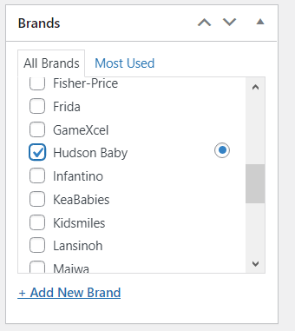

Capture 61 - Choosing brand for the product.

If the brand hasn’t been added yet, simply add a new one by clicking “Add new Brand” then type in the name and click on the “Add new Brand” button.

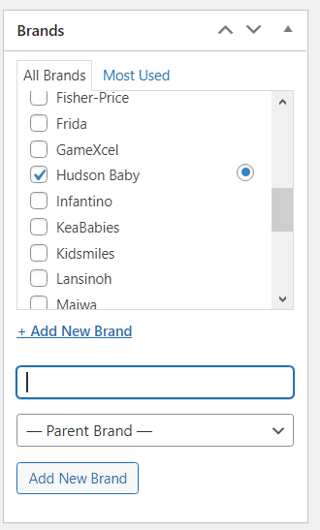

Capture 62 - Quick add new brand while add new product.

Under the Brand box is the Category box. Choose your product’s category and make sure to tick on the parent category as well, with the child category to be the primary category.

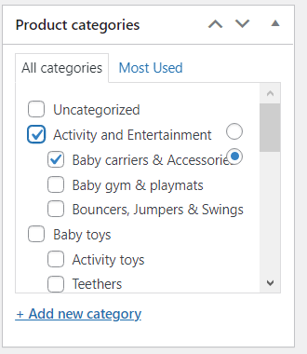

Capture 63 - Tick on the Category of the Product.

If the category hasn’t been added yet, click on “Add new category” and add a new one similarly to adding a new brand. (See Capture 62 as reference)

Under the Category box is the Product Tag box. Type in any tag for your product and click the “Add” button.

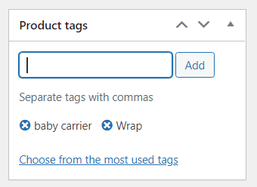

Capture 64 – “Product tags” box.

Scroll down a little bit more and you should see a Rank Math SEO box. This is a feature of the SEO plugin that we have installed on the website. To calculate the rank SEO of the product, type in the focus keywords in the box. To increase SEO further, read all feedback from the plugin under the typing box.

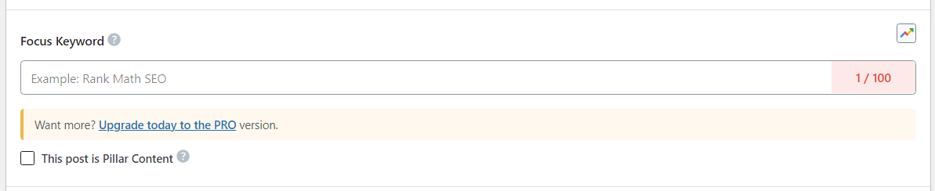

Capture 65 - Type in focus keywords.

Lastly, you have to add some images for your product. At the bottom right of the Add New Product page, there is a “Product Image” box.

Click on “Set product image” and choose/update media for the product.

Click on “Add product gallery images” in the box below and update gallery images for the product.

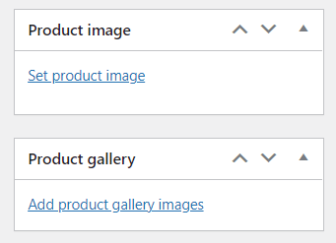

Capture 66 - Product image and Produc gallery box.

Once you finished, click “Publish” or “Save Draft” to save changes. You can also click “Preview” to see the preview first.

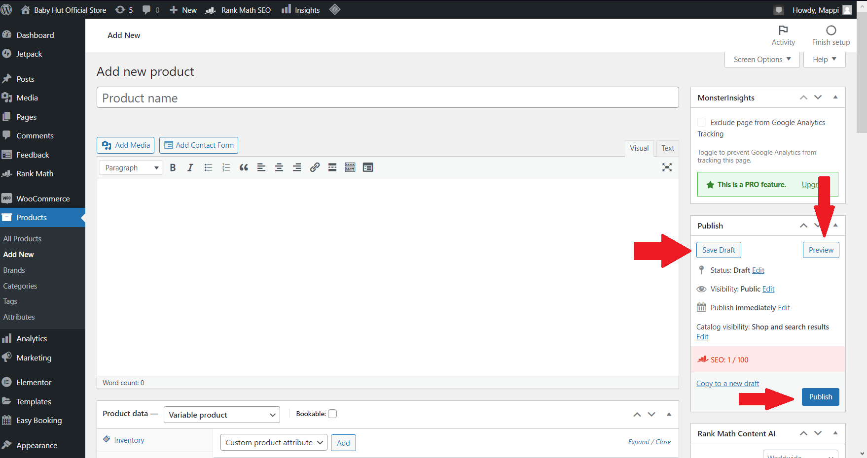

Capture 67 - "Preview", "Save Draft", "Publish" buttons location.

## 8.4. Updating or Removing products.

Click on “All Products” in the Products menu to get access to the Products list.

Hover on any products you want to make changes.

To edit a product, click on “Edit”. Further steps on editing would be the same as shown in Section 8.3.

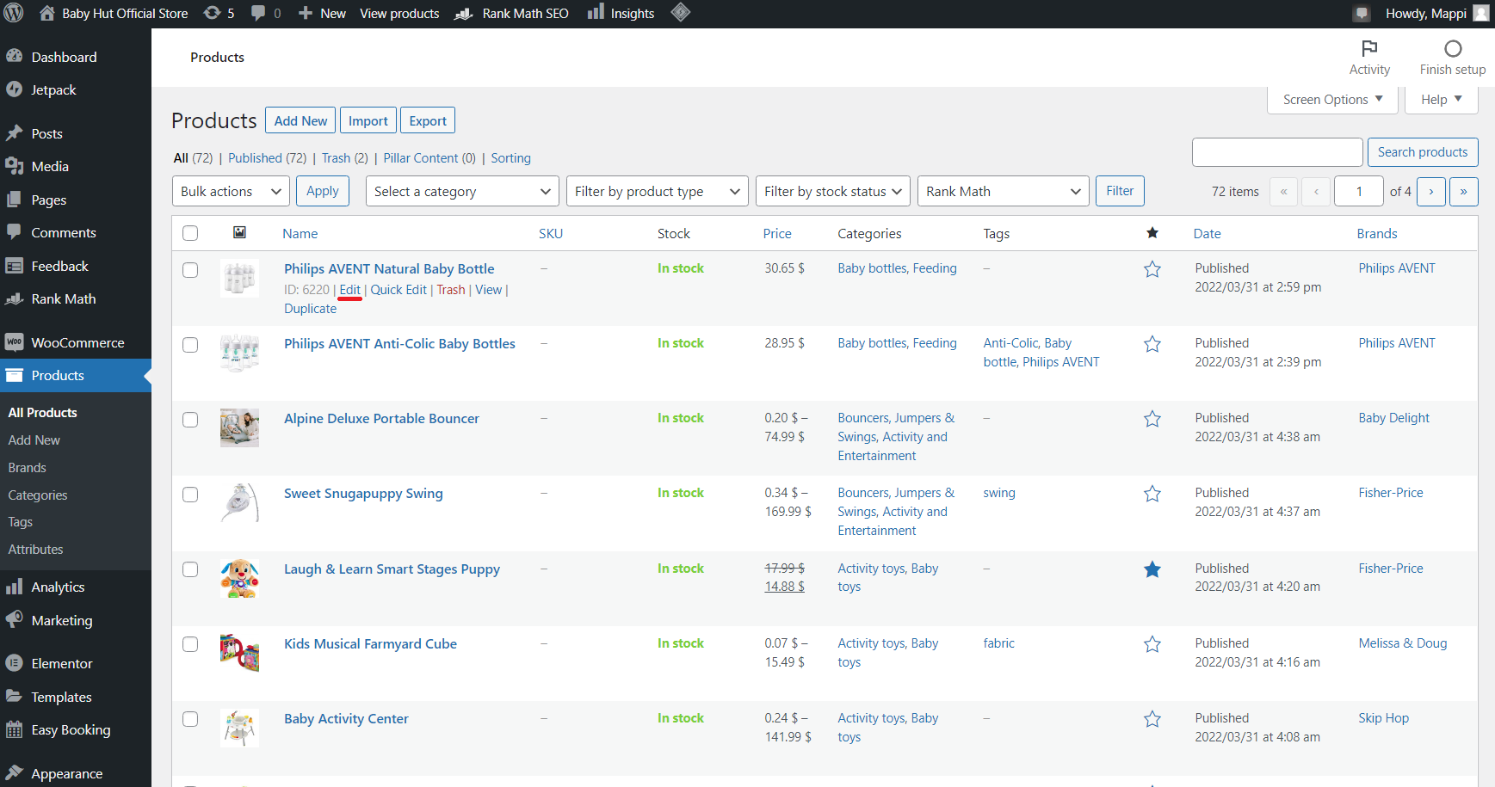

Capture 68 - "Edit" link location.

To remove a product, click on “Trash”. Further steps in this process would be the same as removing a page shown in Section 4.6.

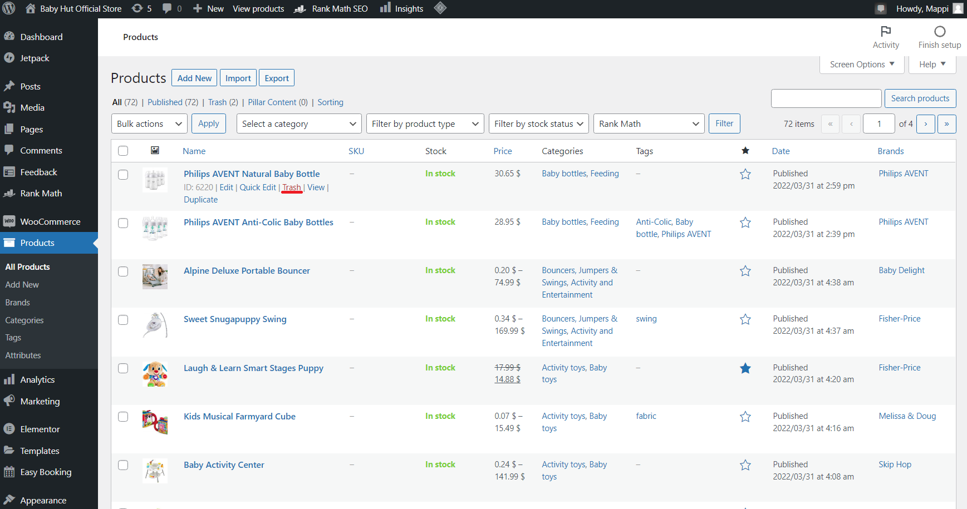

Capture 69 - "Trash" link location.

8.5. Generate coupons.

To make new coupon, hover over “Marketing” then click “Coupons”.

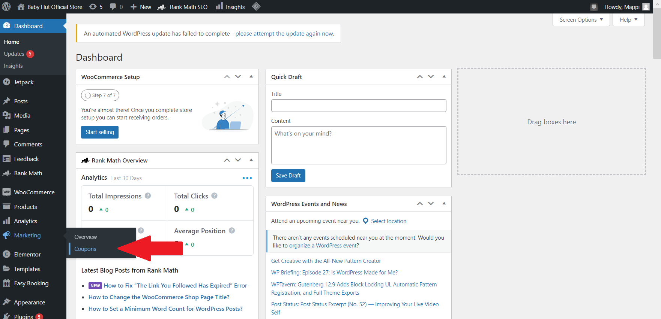

Capture 70 - "Coupons" link location.

Click on the “Add coupon” button to get started. After filling in all the necessary information, click on the “Publish” button to make the coupon official.

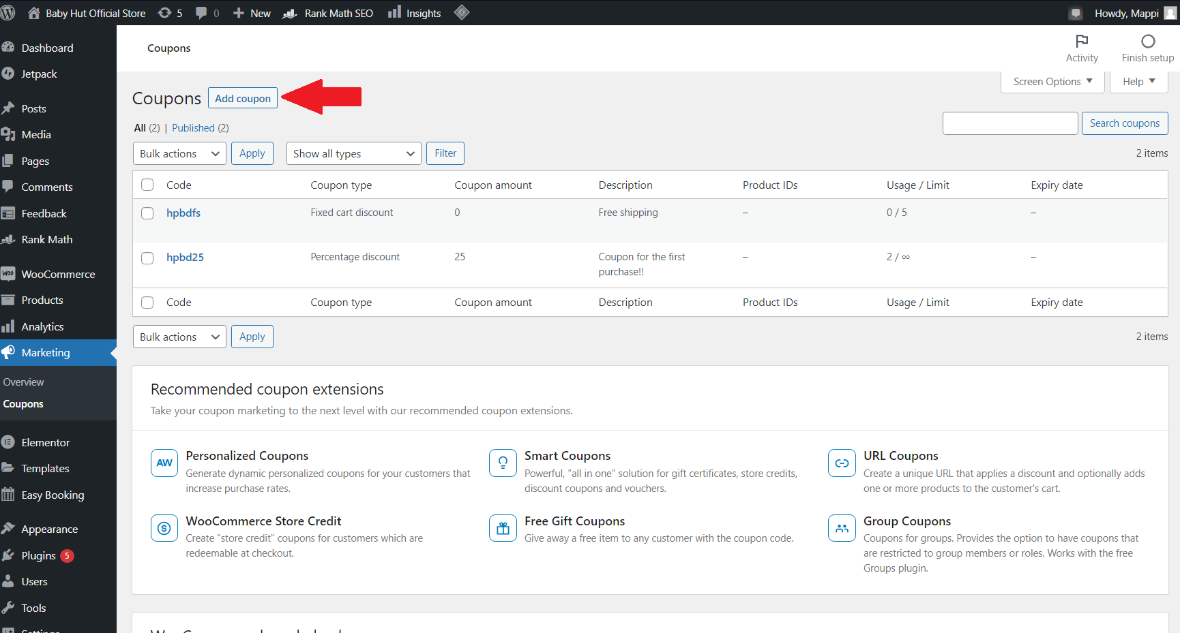

Capture 71 - "Add coupon" button location.

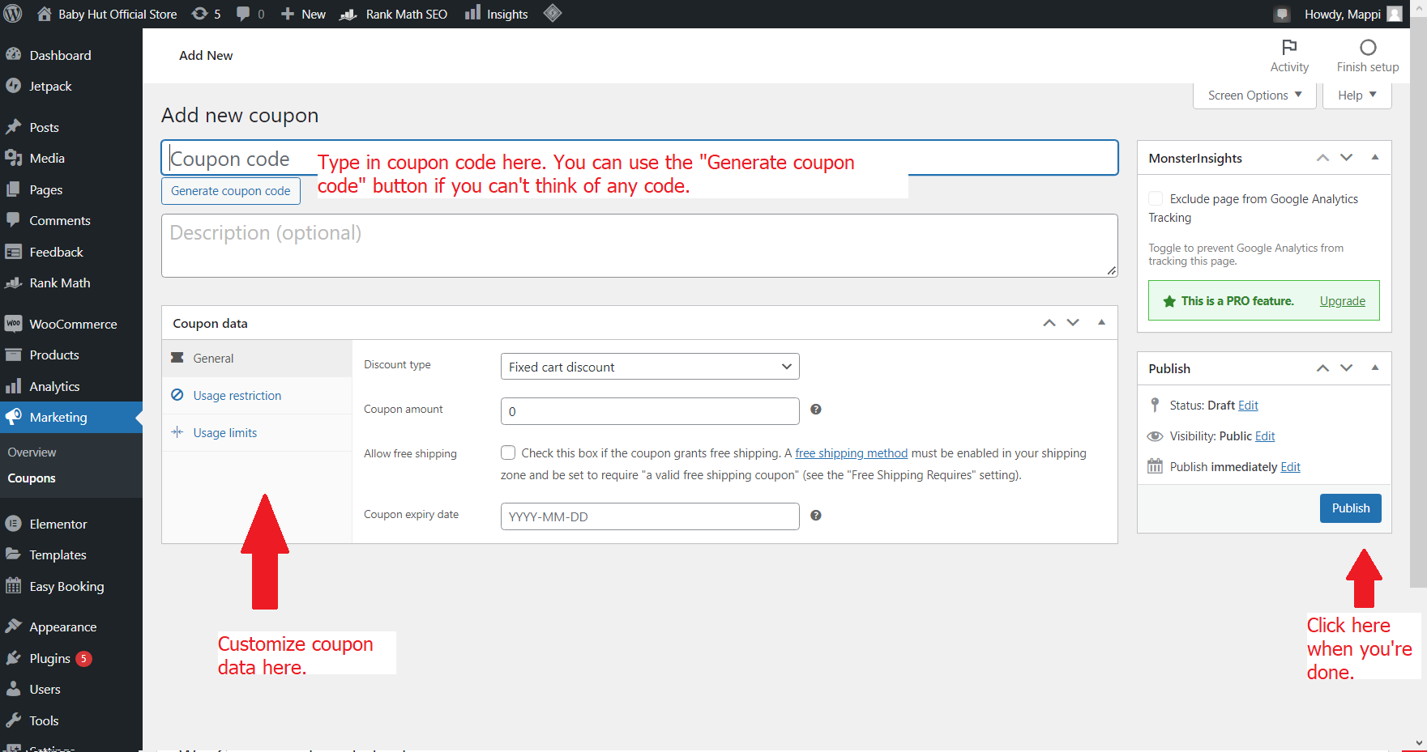

Capture 72 - Add new coupon process.

# 9. Using website analytics.

Click on “Insights” on the left menu.

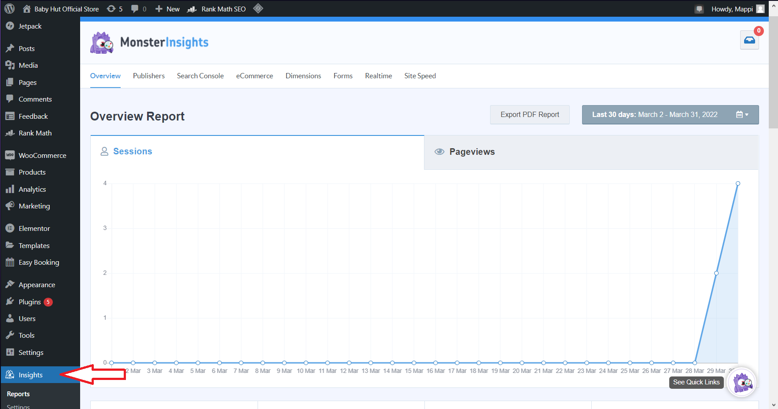

Capture 73 - "Insights" location.

A page of MonsterInsights would show up. This plugin has already been connected with our Analytics account. Therefore, you can use this plugin to observe the report of Website Analytics.

# 10. Generating report and backing up.

## 10.1. Generating reports.

In order to generate a report, go to “WooCommerce” and click on “Reports”. The report is completely automatic, so there is no need for generating.

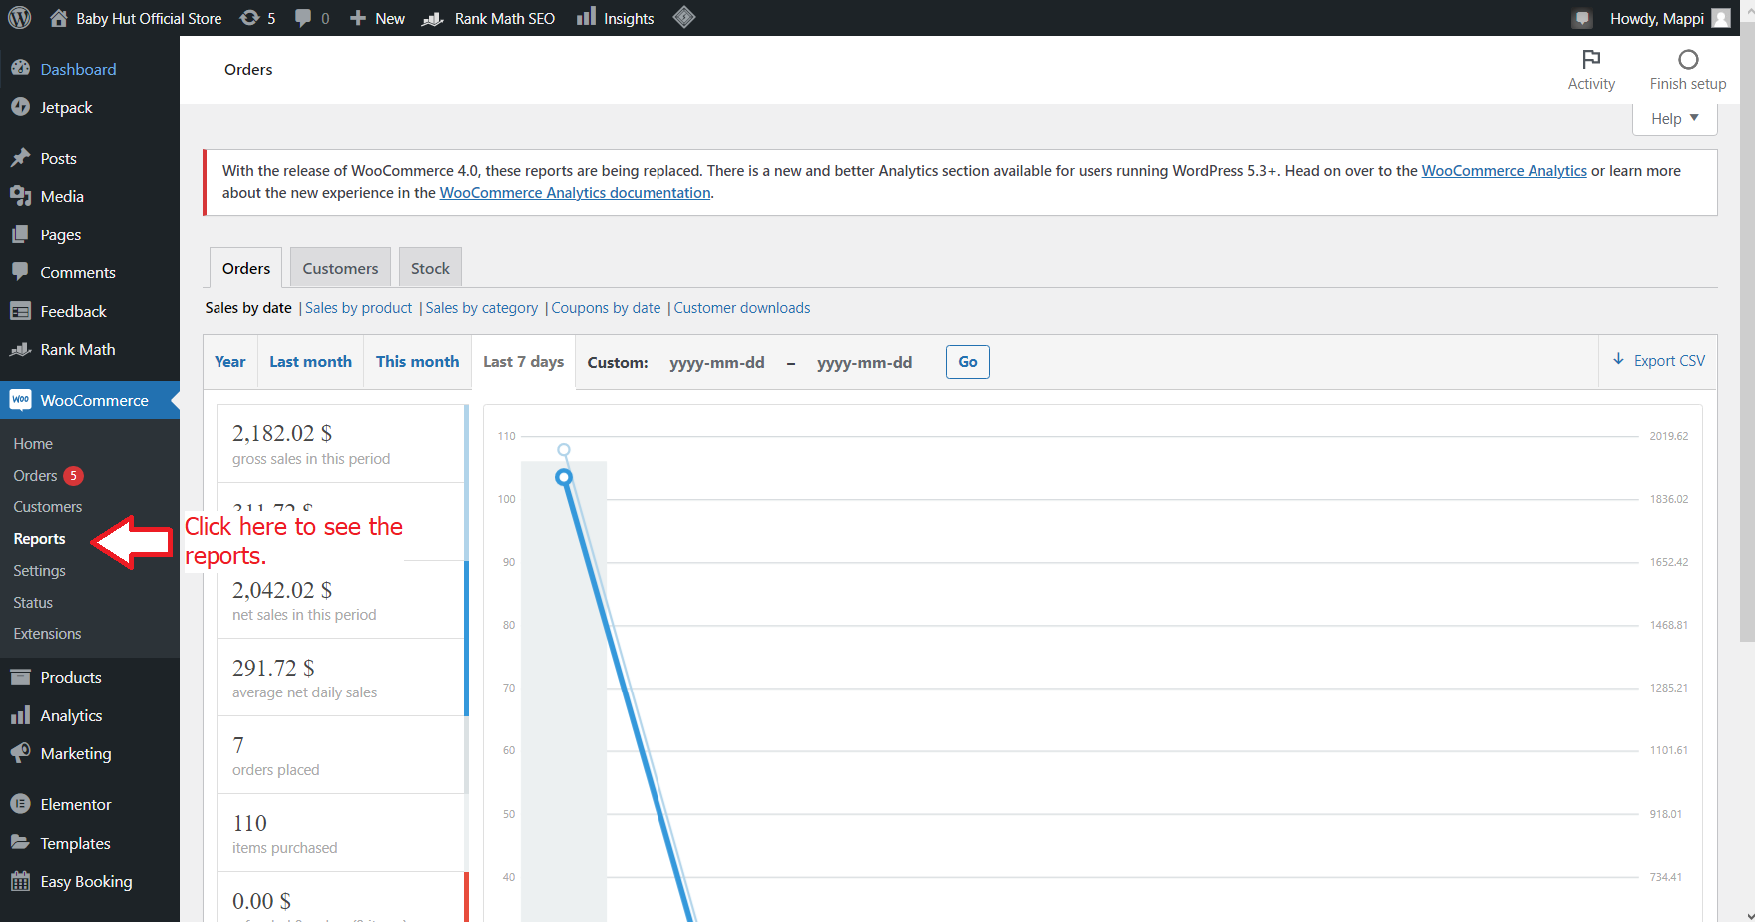

Capture 74 - "Reports" link location.

10.2. Analyse reports.

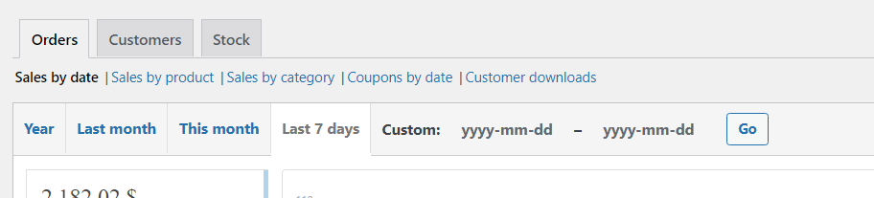

Capture 75 - Options in reports.

It can be seen from the capture above that the Reports section of WooCommerce allows many options to be chosen to analyze the data of the website. As such, you can customize and sort the data in the way that you want, then analyze it based on your business skill.

10.3. Rental reports.

To keep track of rental orders, go to “Easy Booking” on the left menu and click on “Reports”. A rental/booking report would be automatically created based on the orders received and processed.

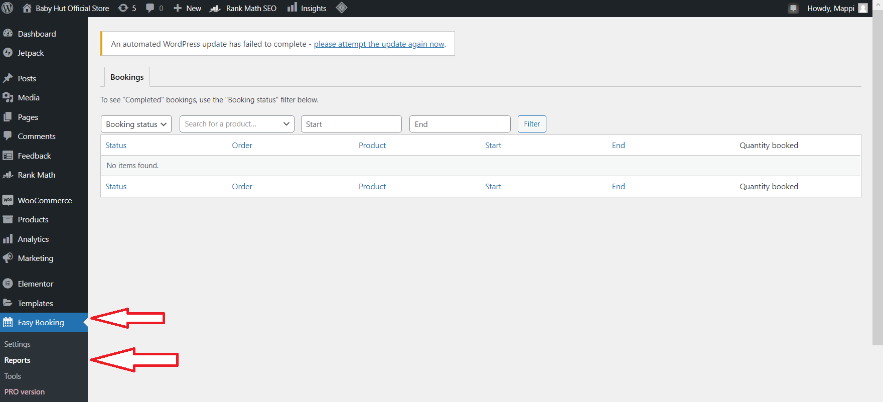

Capture 76 - "Easy Booking" and "Reports" location.

## 10.3. Why backup?

E-commerce stores often receive numerous visits per day. Therefore, valuable information such as orders, customers, reviews, or stock availability of products would be received.

However, online store websites often face the threat of being hacked or sometimes get crashed because of heavy traffic. If these scenarios happen, all data on the website would be gone and there is no way to recover back.

As such, it is important to back up data once per while to ensure data loss in case anything occurs.

## 10.4. How often to backup?

We suggest back up once per 2 to 3 days.

## 10.5. Where to store backups?

We suggest to store on your company computer or on your company cloud storage.

## 10.6. How to website backups?

To backup the website, first, go to cPanel with the account provided in 12.2 section.

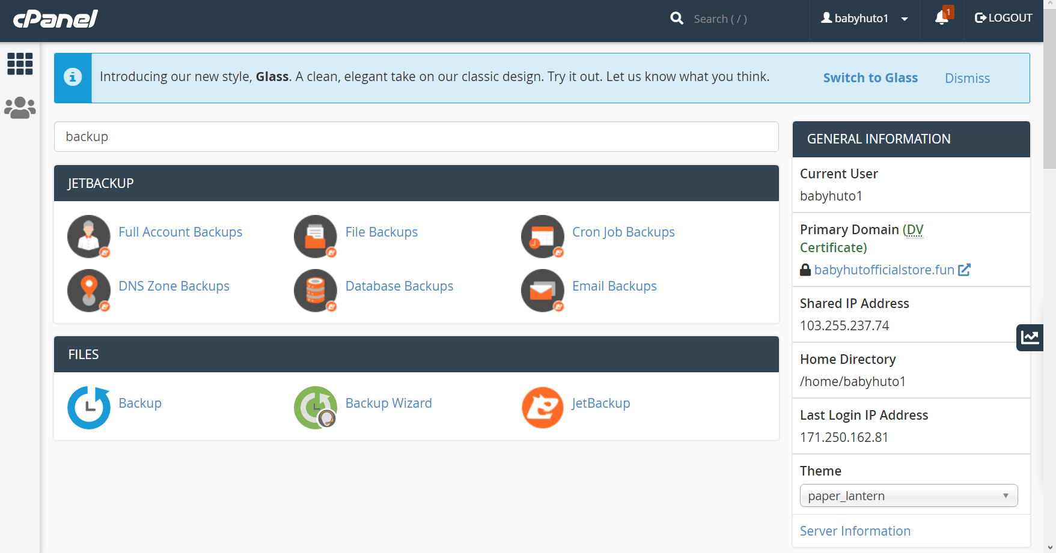

Capture 77 - Search for "backup" on cPanel.

Click on “Backup” to continue, then click on “Download a Full Account Backup” button.

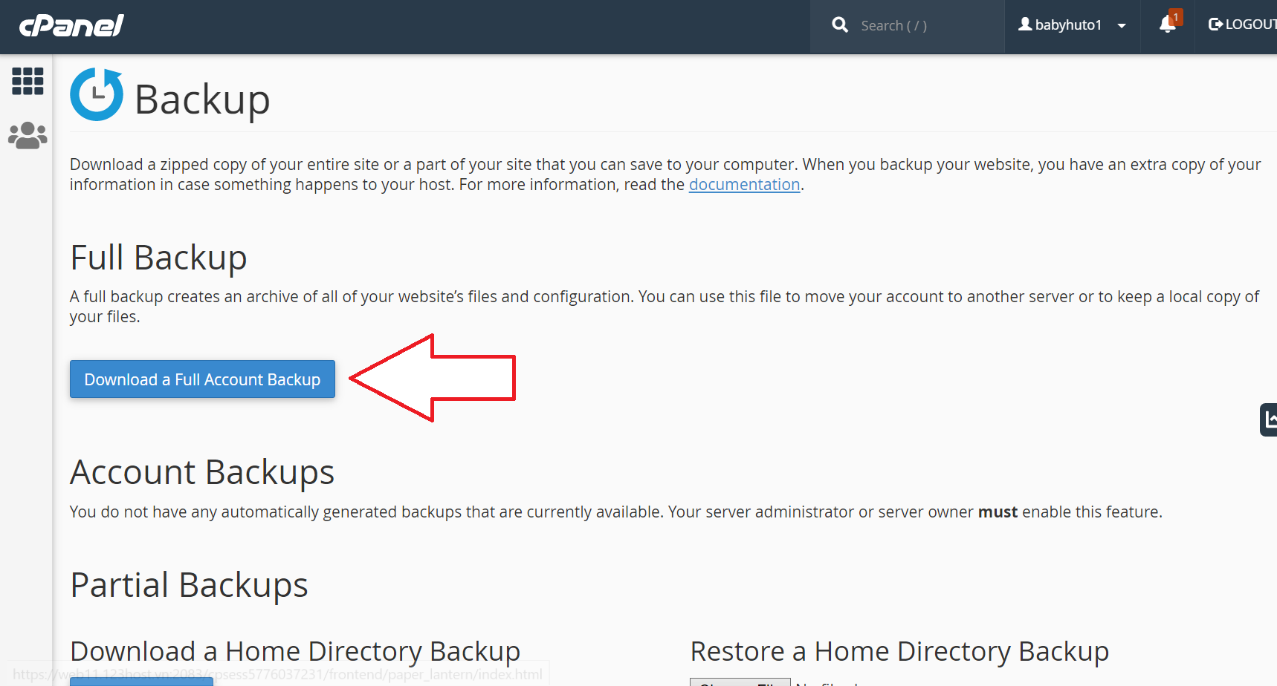

Capture 78 - Button location.

cPanel would then ask for backup destination and email. Type in and click “Generate backup”.

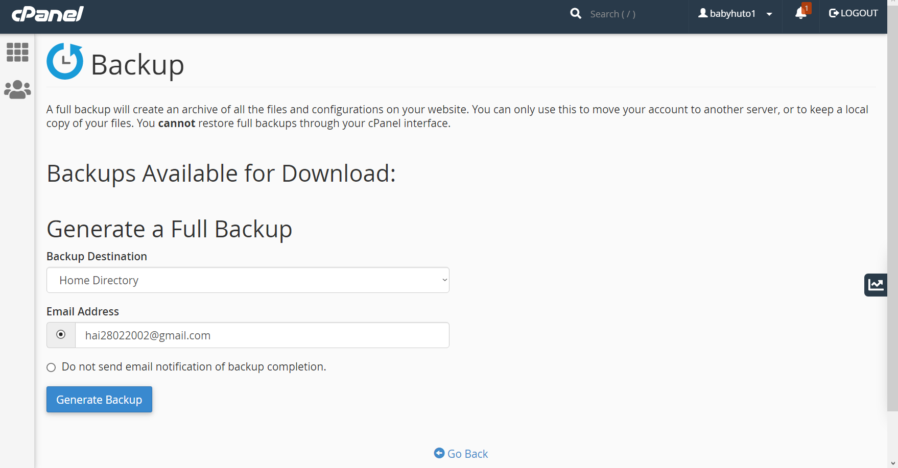

Capture 79 – Type in destination and email.

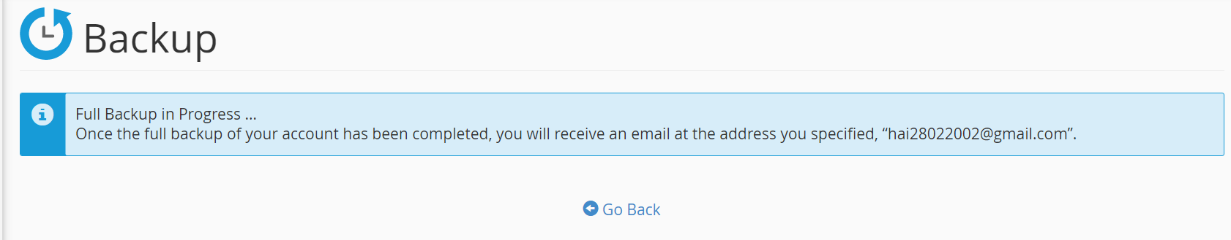

Capture 80 - Generating backup.

If this notification is showing, this means the backup is in progress. You may wait a while for the backup to be complete.

# 12. Technical Summary.

## 12.1. Domain information.

Domain name: www.babyhutofficialstore.fun.

## 12.2. Hosting information.

Hosting server: 123HOST.VN.

cPanel login information:

URL: <https://web11.123host.vn:2083/>

Username: babyhuto1

Password: 0TtbtpngNeAMUt6

## 12.3. Wordpress site.

URL: [www.babyhutofficialstore.fun/ict1001](http://www.babyhutofficialstore.fun/ict1001)

Username: teacher

Password: Ot3q^LWEvs6)O$sXQ!bd3x5K

## 12.4. Google Analytics account.

Email: phuongntmsws00150@fpt.edu.vn.

## 12.5. Social media account.

Facebook: <https://www.facebook.com/BabyHutOfficialStore>

Twitter: <https://twitter.com/hut_store>

Instagram: <https://www.instagram.com/BabyHutOfficialStore/>

# 5. REFERENCE LIST